Where Are Earthquakes Happening Right Now? Worksheet
Objective: To access real-time, real-world USGS seismic data from around the planet through the Earthquake Living Lab website. To evaluate trends in earthquake locations, magnitudes and frequency.
Materials: Work in pairs sharing one computer with Internet access and Microsoft Excel software.
Part 1: Engage, Explore, Evaluate and Elaborate the Earthquake Living Lab Data
Engage:
- Make a list of places around the world where you think earthquakes occur. Think about places you have read about or seen on the news.

- Think specifically about earthquakes in the U.S. What regions or states do you think experience the most earthquakes?

- From your limited data set, predict patterns or trends in the locations of earthquakes. Why do you think earthquakes occur in certain places more often?

Explore: Navigate to the Earthquakes Living Lab at http://www.teachengineering.org/livinglabs/earthquakes/.
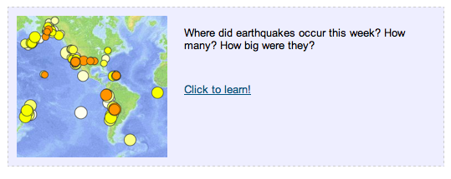
- Notice the Earthquake Living Lab has four main sections based on four historic earthquakes and active seismic areas. For this activity, select the “Chile” box > then under the “Where did earthquakes occur this week?” section on the right side, click on the “Click to learn!” link.
- Take a few minutes to examine the data on the screen. Each circle represents an earthquake that occurred during the last seven days.
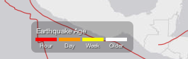
  - What do the dot colors indicate? (Hint: Look at the legend at the bottom of the page.)

  - What does the circle size indicate?

  - Click on one of the circles.
What information is provided?

  - Using the legend, complete a quick visual survey of the map to answer the following questions: (Hint: You may need to zoom out.)
    - Approximately how many earthquakes occurred within the last hour?

    - Approximately how many earthquakes occurred within the last day?

    - Where did the greatest magnitude earthquakes occur this week?

Explain:
- Looking at the website, examine the general location and frequency of earthquakes.
- Describe any patterns or trends you observe in the location of earthquakes.

- How do these actual trends compare to your original predictions in the Engage section above?

- Why do you think most earthquakes occur in these locations and not other places on Earth?

Evaluate:
- Click on the Settings icon (the gear-shaped button) in the upper right:
Then turn on the “U.S. faults” overlay.

- Looking at the newly added red U.S. fault lines, what do you think a fault is? How do you think they are associated with earthquakes?

- Why do you think earthquakes are located along some faults? Do they occur on every fault line?

Part 2: Analyze the Earthquake Living Lab Data
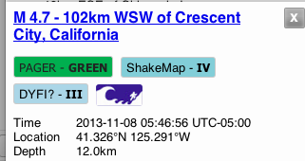
- When you click on a circle on the map, the left part of the screen displays information for that specific earthquake. Make a quick list of available information for your reference (copy a few lines of the chart, or cut and paste an image of it).
California example

- Click on other earthquakes in the list on the left side of the page. What additional information is available to you?

- Perform a cursory (quick) overview of the first 25 most-recent earthquakes on the list. Estimate the maximum, minimum and average magnitude from this data set. (Hint: As necessary, scroll down through the list to see more than the data currently on your screen.)

- Using Excel, perform a detailed analysis of the first 25 most-recent earthquakes on the list.
- Enter (copy) the magnitude values.
- Calculate mean, median, and mode.
- Identify the maximum and minimum magnitudes.
Elaborate:
- Imagine if you had an entire year’s worth of data to analyze.
- Do you think the mean, median, or mode would change?

  - If yes, why do you think it would change and by how much? Estimate it.

  - If no, explain why it would not change.
- Do you think the maximum and minimum magnitude values would change?
  - If yes, why do you think it would change and by how much (estimate it)?

- If no, explain why it would not change.
Congratulations—you have completed this activity! This is only a small part of all there is to know about earthquakes, and researchers are learning new things all the time. Feel free to come back to this resource to keep learning as often as you like.

