The Theory of Plate Tectonics Worksheet

Example Answers
Objective: Gather evidence to explain the theory of plate tectonics.
Materials: Work in pairs sharing one computer with Internet access.
Engage:
- What continent do you live on? Can you think of any ways the continent has changed over time?
Answers will vary.
Explore: Navigate to the Earthquakes Living Lab at http://www.teachengineering.org/livinglabs/earthquakes/.
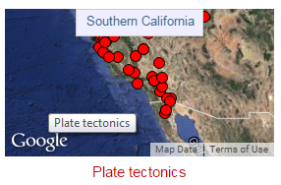
Notice the four main components of the Earthquakes Living Lab.
- Select the second option, the “Southern California” box. > click the third link on the right side of the page titled, “How have the Earth’s continents changed over time?” at http://www.ucmp.berkeley.edu/geology/anim1.html.
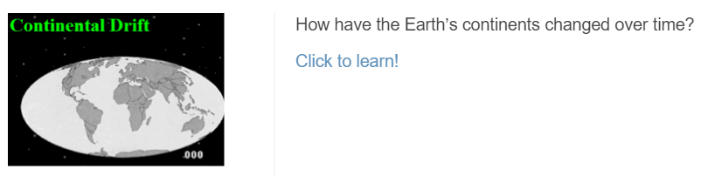

- Compare the map of the world today (such as the real-time earthquake map) to a map of the world 250 million years ago (called Pangaea). Use the interactive continental drift map to watch the change in the Earth’s landforms over millions of years.
- As you watch the animation, record at least three examples of how the continents have changed their positions over time.
Answers will vary. Expect students to describe how some landforms started as one mass and have separated, or how other landmasses have moved to different locations.
- If the plates continue to move in this pattern, draw a sketch of what the world might look like 250 million years in the future.
Sketches will vary. Grade sketches based on logic and completeness.
- Explain: Navigate back to the Earthquakes Living Lab main page and click on the second and fourth links titled, “What is the theory of plate tectonics? What evidence supports the theory of plate tectonics?” and general information on plate tectonics. Explore more about the theory. Read the background information and answer the following questions:

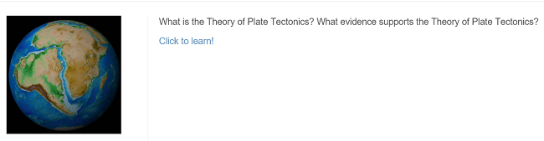

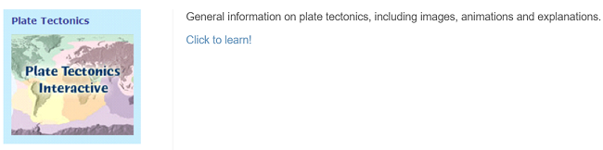

- What might have caused the continents to move? (Hint: What is the name of this theory?)
Plate tectonics and their drifting

- Describe some important information related to this theory.
Answers will vary. Students may report information such as: Seven main plates (Eurasia, North America, Africa, South America, India, Australia and Antarctica) have diverged, converged or transformed over millions of years. Some coastlines are similar in shape and appear to “fit.” Unique fossil and rock similarities across ocean basins suggests continental movement shifting and drifting away from each other. The continuation and breaking of mountain chains, coral reefs and glacial deposits, as well as the locations of earthquakes and volcanic activity suggests the same. Additional ideas suggest why the plates move—perhaps due to convection currents and the Earth’s magnetism, as seen in the resulting ocean bases, trenches and ridges.
- Elaborate: Find and record evidence used to explain how continents have moved over time. Explore the following links to identify explanations and examples of evidence. You may also use any of the other links located on the Earthquakes Living Lab page. Use a graphic organizer (such as the chart below) to record your ideas.
- Seafloor spreading and earthquakes: http://pubs.usgs.gov/gip/dynamic/developing.html
- Fossils : http://aquarium.ucsd.edu/Education/Learning_Resources/Voyager_for_Kids/earth_puzzle/
- Volcanoes: http://www.divediscover.whoi.edu/hottopics/seamounts.html
Category | Evidence Examples and Explanations
sea floor spreading | - Fred Vines’ Atlantic mid-ocean ridge symmetrical magnetic stripes  - Age-dating sediments on either side of a ridge indicate the sediments get progressively older away from the mid-ocean ridge axis  - Thickness of sediments also increases away from the ridge
fossils | - Fossil similarities: mesosaurus fossil, between Africa and South America  - Identical plant fossils found on several continents  - Dinosaur fossils found cross-continental  - Rocks of same age found across ocean basins
earthquakes | - Earthquakes occur along plate margins, ocean trenches and spreading regions  - “Wadati-Benioff Zones” are identified as prominent earthquake zones  - Pervasive seismic mapping of the earthquake concentration zones worldwide
volcanoes | - Volcanoes occur along hot zones at plate boundaries  - Underground volcanoes are “seamounts”  - A line of seafloor volcanoes indicates the direction a tectonic plate is moving
- Looking at the information you compiled in your chart above, explain one way the theory of plate tectonics can relate to engineering.
Examples will vary. Expect students to say something about how engineers must understand the processes that shape the Earth in order to design safe structures that are able to withstand powerful natural events. This especially applies to construction projects located near active faults and coastlines where the release of seismic wave energy can damage and destroy human-made structures. Engineers must understand the properties and movement of the Earth’s crust in order to design adequate foundations for structures. Often, their designs include extra factors of safety to account for the anticipated forces from natural events like earthquakes and volcano eruptions.
- Evaluate: In the early 1900s Alfred Wegener proposed the continents were “drifting.” The scientific community did not support his theory due to a lack of scientific evidence. Using what you learned in this activity, would you support Wegener’s hypothesis or not? Write a two-paragraph essay that explains your position.

