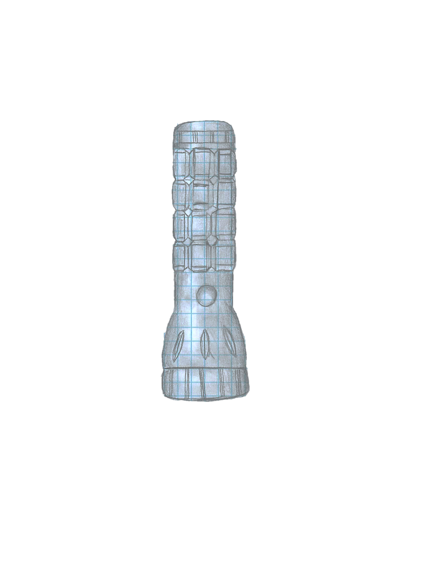
Re

Flashlight manual

How the flashlight works

A flashlight is powered by batteries. They create an electrical current that flows through metal contacts and brings electricity to the lamp in the flashlight. A thin wire in the light bulb is connected to the batteries.

table of content………………………………………………………………
Table of Contents

Flashlight parts …………..…………………………………………………………………………………….. Pg.3

How to put it together, step by step…………………………………………………………………….. Pg.4

Bill of materials ………………………………………………………………………………………………….. Pg.5

Purpose of the flashlight …………………………………………………………………………….…….. Pg.6
- What is a flashlight?
- How does a flashlight work?
- How to use it?
Wrap-up manual ……………………………………………………………………………………………….. Pg.7
Team contract …………..……………………………………………………………………………………….. Pg.7
Conclusion …………………………………………………………………………………………………………. Pg.8
- Improvements 1 ……………………………………………….……………. Pg.8
- Improvements 2 ……….………………………………………………….... Pg.9
- Feedback ………………………………………………………………………. Pg.9
- Teamwork evaluation ……………………………………………………. Pg.9
- Conclusion ………….………………………………………………………….. Pg.10

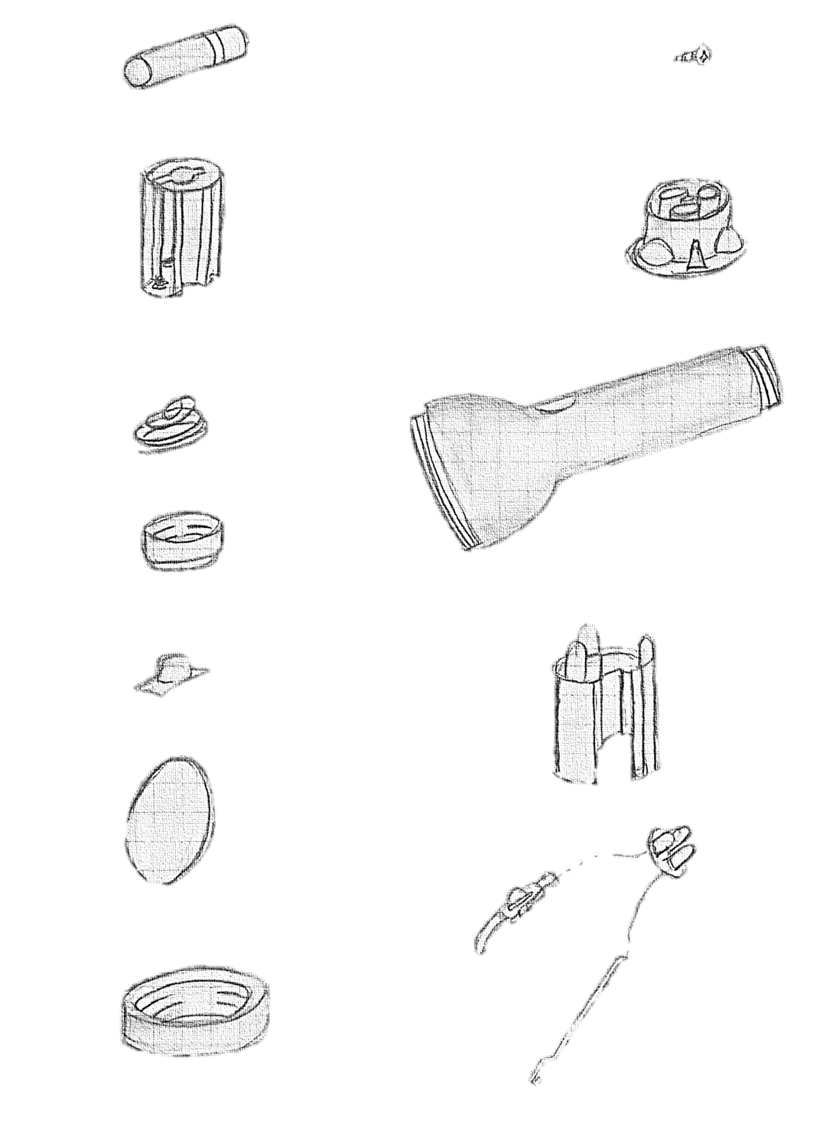
battery
screw

battery holder
halogen lamp
face cap
lamp protector
frame
switch seal
lens
reflector
battery spring
tail cap
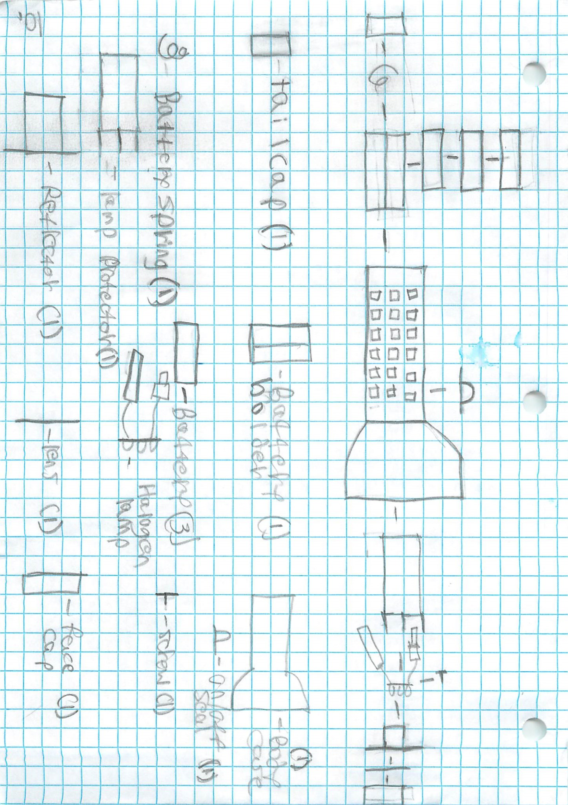
Step-by-step: How to put the flashlight together
- Put the battery spring and place it in the tail cap.

- Take the batteries and put them in the battery holder.

- Place the lame protector inside the frame from the top of the frame.

- Put the battery holder inside the frame from the bottom.

- Put the tail cap on the frame from the bottom, then close it.

- Put the halogen lamp in the reflector.

- Put the reflector with the halogen in it inside the frame from the top.

- Put the lens in the face cap.

- Put the face cap on the frame form the top, then close it.

- Put the switch seal in the hole in the center of the frame.
Bill of Materials
Bill of materials for: |  |  | Names:
Product # | Name | Qty | Dimension | Function | Interaction  with other parts | Research cost | Website
1 | lens | 1 |  | protect the light | keeps the light protected | 15 ¢ | EBay
2 | battery | 3 |  | energy | energy source | $1.80 x3 | EBay
3 | reflector | 1 |  | reflect the light | reflects light from the light bulbs | 1.42 | EBay
4 | tail cap | 1 |  | keeps the battery in | holds the batteries in | 99 ¢ | EBay
5 | face cap | 1 |  | holds the lens | holds the lens and the lights | 70 ¢ | EBay
6 | battery spring | 1 |  | for electrical current | used as an electrical current | 27 ¢ | EBay
7 | screw | 1 |  | holds the halogen light | holds the light in place | 31 ¢ | EBay
8 | battery holder | 1 |  | holds the batteries | connects batteries to the lights | 1.19 | EBay
9 | switch seal | 1 |  | turns it on and off | turns the light on and off | 70 ¢ | EBay
10 | halogen lamp | 1 |  | project light | gets power from the batteries | 60 ¢ | EBay
11 | lamp protector | 1 |  | protects the light | protects and holds the light | $1.05 | EBay
12 | frame | 1 |  | holds everything together | holds all the parts | $1.18 | EBay

Purpose of the Flashlight
- What is a flashlight?

A flashlight is a portable electrical light source, in which the light source is connected to batteries by a small thin wire.

- How does a flashlight work?

A flashlight is powered by batteries. They create an electrical current that flows through metal contacts and brings electricity to the lamp in the flashlight. A thin wire in the light bulb is connected to the batteries.

- How to use a flashlight?

The use of a flashlight is very easy; it is a simple-to-use device. You only need to move the switch to make a flashlight work. The switch is located at the center of the frame.

Wrap-Up manual
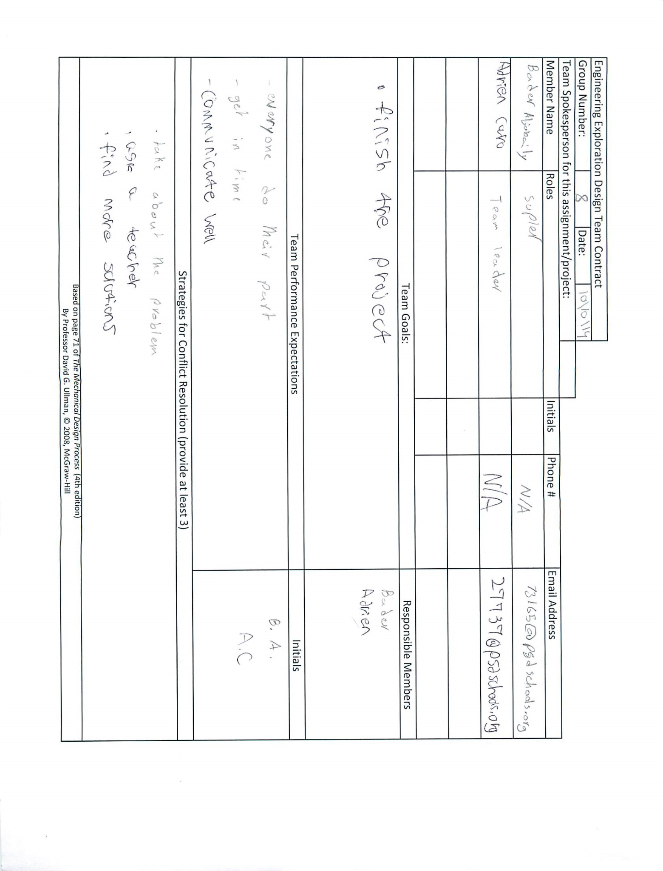

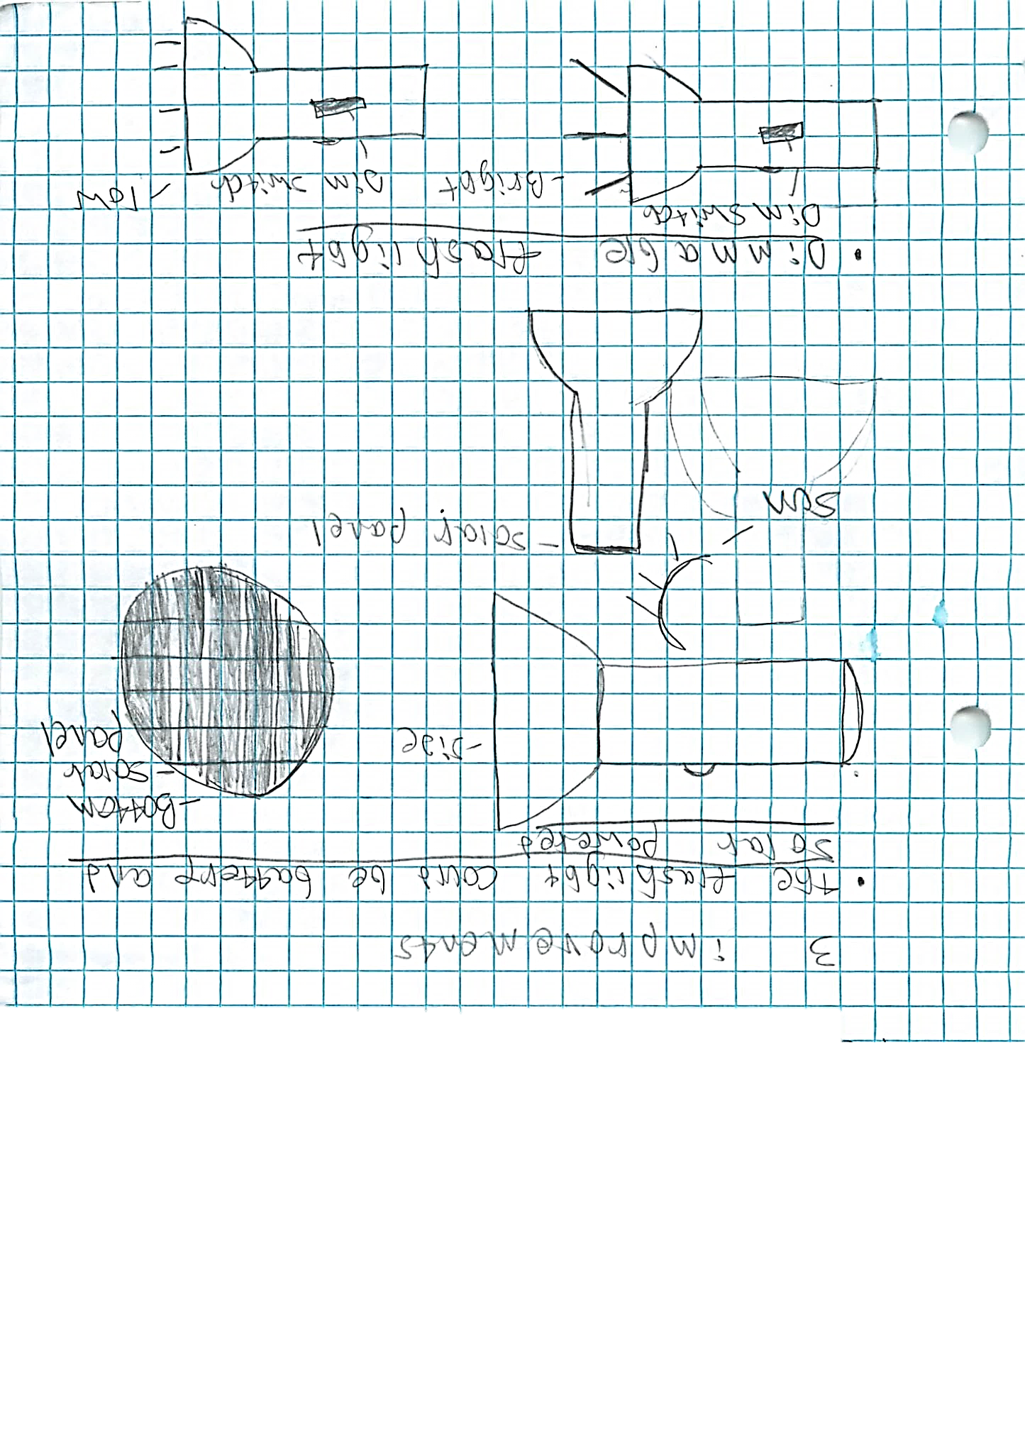
Conclusion

