Air Quality and Particulate Matter (PM) Datasheet – Answer Key
How can we know how clean and healthy the air is?

Together, we are going to find out:
- How can we measure how clean (healthy) the air is that we breathe?
- Does the air carry particulate matter (PM)?
- What should we do when the air is dirty (unhealthy)?

1. Let’s figure out how air quality is measured and why it’s important to know.
First, watch the Wildfires in the West Cause Air Pollution. Do a think-pair-share on what you observed:
- Why do wildfires cause air pollution? Wildfires emit smoke and ash, which are particulate matter or PM for short, which is a primary type of air pollution.
- What happens to the air when there is a wildfire? Hazy, hard to see and difficult to breathe.
- How do you think wildfire smoke travels so far away? Weather, especially wind blows PM.
The Air Quality Index, or AQI for short, is a rating system that tells us how healthy the air outside is.
- Watch Why is Coco Orange? to learn about how air quality is measured.
- What does Coco say you should do when the air outside is not healthy? Spend less time outdoors, limit activity levels outside, and play inside instead.
- As a class, look at the Air Quality Index chart.
- What information does it tell? Air Quality in relation to values 0-300, corresponding colors, and health risks at each level
- Which colors mean the air is healthy? Green, yellow
- Which colors mean the air is unhealthy? Orange, red, purple

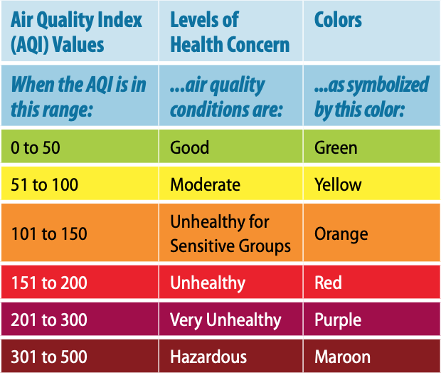

- Use the AQI chart to help you complete the “What Color is Your Air” activity sheet for grade K or grades 1-2. Answers vary on data collected.
2. Wind and PM Data Table: Collect data at your school!
Date  Write down the date that you record data each day. | Wind Direction  Use the Wind Streamer to observe which direction the wind is blowing from.  Circle the wind direction on the compass. | Wind Speed  Estimate the wind strength by observing trees, flags, etc.  Check the box that matches how much the wind is blowing | PM 2.5 Level  Write the PM 2.5 number from AirNow.gov | Air Quality Color  Color the circle to match the PM level  (green, yellow, orange, red, or purple)
Day: 1  Date: | 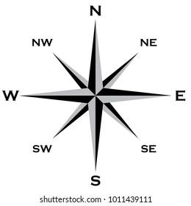 | ⃞ No Wind  ⃞ Light Wind  ⃞ Strong Wind | PM 2.5 level: | PM 2.5 Air Quality Color:
Day: 2  Date: |  | ⃞ No Wind  ⃞ Light Wind  ⃞ Strong Wind | PM 2.5 level: | PM 2.5 Air Quality Color:
Date | Wind Direction | Wind Speed | PM 2.5 Level | Air Quality Color
Day: 3  Date: |  | ⃞ No Wind  ⃞ Light Wind  ⃞ Strong Wind | PM 2.5 level: | PM 2.5 Air Quality Color:
Day: 4  Date: |  | ⃞ No Wind  ⃞ Light Wind  ⃞ Strong Wind | PM 2.5 level: | PM 2.5 Air Quality Color:
Day: 5  Date: |  | ⃞ No Wind  ⃞ Light Wind  ⃞ Strong Wind | PM 2.5 level: | PM 2.5 Air Quality Color:

3. PM Catcher: Use a hand lens to count how many PM 10 particles are trapped.
PM 10 pieces are bigger than PM 2.5 pieces. PM 10 pieces are big enough to see but PM 2.5 are too small to see.

- Place your PM Catcher in the space below (sticky side down for tape, sticky side up for Vaseline)
- Using a hand lens to view, look closely to see if it contains small pieces of PM 10.
- Can you see PM 10 pieces? If yes, count how many pieces are on the PM Catcher.
Write the number of PM 10 pieces: __________
Answers vary on data collected.
4. Let’s analyze our PM 2.5 data and PM Catcher results.
Review the Air Quality Index (AQI) below and the Wind and PM Data Table where you recorded data in Section 2 of the datasheet.

- Look at your data table. Count the number of PM 2.5 air quality days for each AQI color:
- Number of green days 🌝: Answers will vary according to data
- Number of yellow days 🙂: Answers will vary according to data
- Number of orange days 🙁: Answers will vary according to data
- Number of red days 🙁: Answers will vary according to data
- Number of purple days 🙁: Answers will vary according to data
- We’re there more good air quality days or bad air quality days? Circle your results:
🙂 More clean, healthy air days 🙁 More dirty, unhealthy air days
- Circle the type of PM Catcher you made: Tape Vaseline
- Was PM on your PM Catcher? No Yes If Yes, number of PM pieces: _______
Class Reflection: Share your thoughts on the following questions as a class:
- What did you enjoy in learning about air quality (AQ)? Answers vary
- Explain what PM pollution is in your own words. PM are small pieces that are in the air and can be blown by the wind.
- How do the AQ colors help us know how good or bad the air is? Certain colors mean the air is healthy/unhealthy to breathe (green, yellow)/(orange, red, purple).
- What is one thing we should do when the AQ is not healthy? Limit time outdoors playing, etc.

