Carbon Emissions: Pardon My Carbon Worksheet
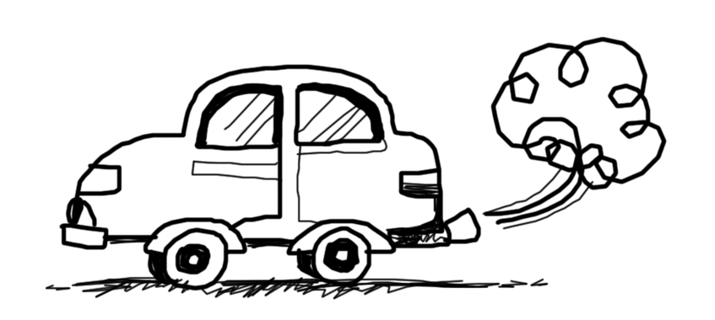
Problem:
Carlota’s running late for work! She just missed the bus and now must get to her office on time, so her boss does not fire her. Every day at work, Carlota must fill out a Trip Tracker to be considered for a bonus. On the Trip Tracker, the fewer carbon points Carlota has, the better her chances of getting a bonus. Help Carlota find the best way to get to work that also helps her get her Trip Tracker bonus!
Constraints (limits):
Carlota has 30 minutes to get to her office on time and only $25 in her wallet, some of which she must save for lunch.
Transportation Trade-offs:
Remember, each mode of transportation comes with a cost! Although driving your car is the fastest, the carbon cost is also the highest. Although walking costs zero money and has the highest health benefit, it also takes the longest. For convenience, you may trade off being environmentally friendly. For being healthy you may trade off convenience. You should keep these trade-offs in mind while answering the questions below. Review the table pros and cons:

Table 1. Transportation Trade-Offs
Transportation  Choice | Travel Time | Travel Cost | Carbon Cost  (3=high carbon footprint, 0=low carbon footprint) | Health Benefits  (10=high, 0=low)
Car | 10 Minutes | $20 | 4 | 0
Carpool | 15 Minutes | $10 | 3 | 5
Bus | 20 Minutes | $5 | 2 | 7
Bike | 25 Minutes | $0 | 1 | 10
Walk | 30 Minutes | $0 | 0 | 10

Imagine (brainstorm):
Brainstorm several pros/cons for the transportation modes listed above. Which mode of transportation do you think is best?

Design a Process (prototype):
Part 1: Carlota is running late for work every day this week! Using the Table 1 Transportation Trade-Offs above, which mode of transportation should Carlota use on each day, Monday-Friday? You can only use the same method of transportation twice in these five days, for example, you can have Carlota use the bus on Monday and Tuesday, but she must use a different method of transportation for the rest of the week.

Part 2: Carlota is running late for work the following week as well! Using the following Trip Tracker Table 2, which mode of transportation should Carlota use each day considering the travel challenges, constraints, and carbon footprint costs?

Table 2. Carlota’s Trip Tracker
 | Monday | Tuesday | Wednesday | Thursday | Friday
Travel Challenge | Gas shortage! The price of gas has doubled and so have the travel costs. | It is snowing and Carlota must look good for an important meeting! | Carlota is running extra late and only has 15 minutes to get to work. | Carlota only has $10 in her wallet, and she must save some money for lunch. | Carlota’s office is offering an extra $10 for folks choosing a healthy way to get to work!
Weather | Sunny | Snowy | Sunny | Sunny | Sunny
Travel Cost | Car - $40  Carpool-$20  Bus - $10  Bike - $0  Walk - $0 | Car - $20  Carpool-$10  Bus - $5  Bike - $0  Walk - $0 | Car - $20  Carpool-$10  Bus - $5  Bike - $0  Walk - $0 | Car - $20  Carpool-$10  Bus - $5  Bike - $0  Walk - $0 | Car - $20  Carpool-$10  Bus - $5  Bike - $0  Walk - $0
Time | 30 minutes | 30 minutes | 15 minutes | 30 minutes | 30 minutes
Money in Wallet | $25 | $25 | $25 | $10 | $25
Health Bonus | $0 bonus | $0 bonus | $0 bonus | $0 bonus | $10 bonus
Travel Solution & Carbon Footprint Cost: Circle your choice to get Carlota to work on time each day. | Car=4  Carpool=3  Bus=2  Bike=1  Walk=0 | Car=4  Carpool=3  Bus=2  Bike=1  Walk=0 | Car=4  Carpool=3  Bus=2  Bike=1  Walk=0 | Car=4  Carpool=3  Bus=2  Bike=1  Walk=0 | Car=4  Carpool=3  Bus=2  Bike=1  Walk=0
Test (prototype feedback): Write your ideas in the space below:
- Using the workspace below, add up the total Carbon Cost for getting Carlota to work during the week. Circle the answer to determine Carlota’s “carbon footprint” for her travel choices (a bigger carbon footprint means more carbon cost; a smaller footprint means less cost):
  - 20-16: Carlota has a high carbon cost (big carbon footprint)
  - 15-11: Carlota is taking steps to reduce her carbon cost.
  - 10-6: Carlota is shrinking her carbon footprint
  - 5 or less: Carlota has a very low carbon cost (small carbon footprint)
Reflection discussion:
- Describe the process that helped you decide the best way for Carlota to get to work each day?
- Which categories (weather, travel cost, travel time, available money, health bonus, carbon cost) are most important in making your travel solution decisions?
- Looking back on the “Imagine” section, did you change your mind on what form of transportation that you think is best? Why or why not?

