How to Build an Arch Handout
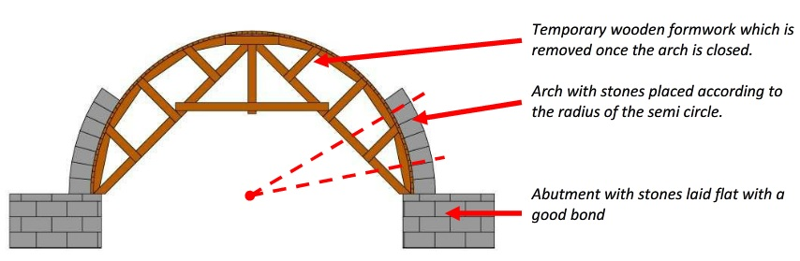

Step 1
Build a base for your arch support structure using wooden blocks and Popsicle sticks. This is the part that lifts your arch into the air. Feel free to break the wooden sticks into smaller pieces to save materials. Make the base slightly smaller in width than your support structure so that it may rest on it, as seen in the diagram above. You do not have side supports, so use hot glue to hold together the structure.
Step 2
Once the base is at the desired height, place your arch support structure on top of it such that you have room on both sides to start placing the blocks for the arch.
Step 3
Now start placing your blocks to form the arch. Feel free to glue the blocks as you go or after it is fully built; either way, make sure not to glue the support structure to the blocks since you need to use it again and again as you construct the other arches.
Step 4
Once the arch is built and the blocks are glued together, remove the arch support and start from step 1 again to create the other arches.

Image source: 2013 Stone Arch Bridges, Chapter 1, page 4, Practical Action CC BY-SA 3.0 http://answers.practicalaction.org/our-resources/collection/stone-construction-1 https://creativecommons.org/licenses/by-sa/3.0/

