Dust in the Respiratory System
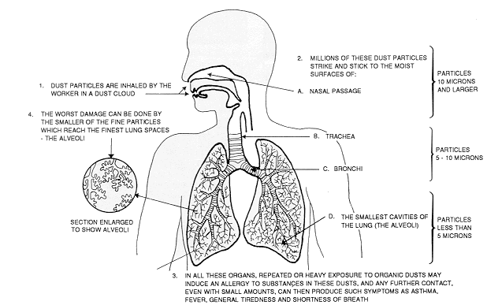

Source: Ontario Ministry of Agriculture, Food and Rural Affairs, http://www.omafra.gov.on.ca/english/livestock/swine/facts/93-003f1.gif

