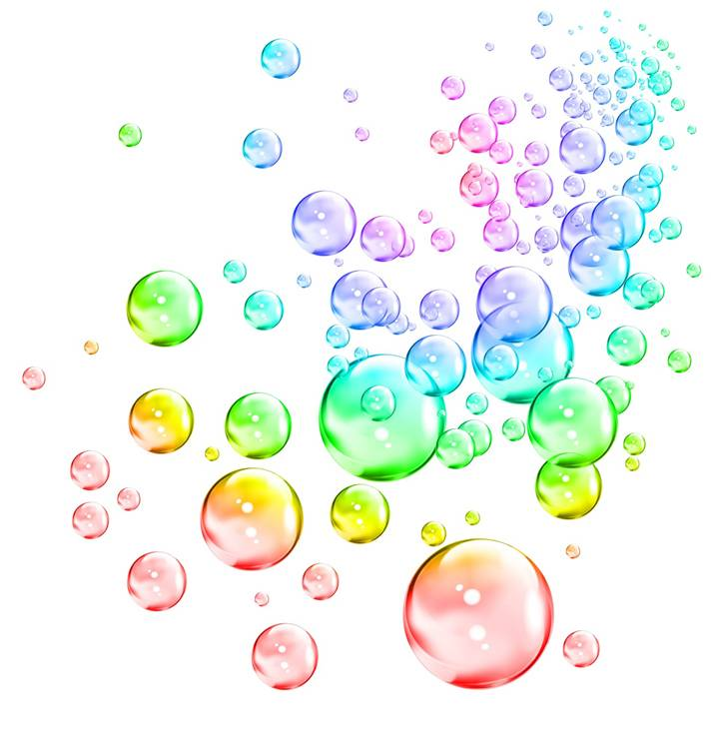
Breathing Cells Activity –
Breathing Bubbles Worksheet
Observations
Record the pH colors of the four unknown solutions. What do you think
each solution is?
Solution #1: color of indicator: _______________ What is it? __________________
Solution #2: color of indicator: _______________ What is it? __________________
Solution #3: color of indicator: _______________ What is it? __________________
Solution #4: color of indicator: _______________ What is it? __________________
What is the color of the indicator before breathing into it? _______________
Record how many breaths it takes to change the indicator color (list results in table below):
 | Number of Breaths
 | At rest… | After exercising…
Trial 1 (partner #1)
Trial 2 (partner #2)
Results
What color did the indicator change? Why?

Did the indicator change more quickly after exercising or at rest? Why?

Did the indicator change more quickly depending on which partner was blowing in the straw? Why?

Graphing
Create a histogram showing the differences between the number of breaths at rest and the number of breaths after excercising for each trial.

Engineering and Bioremediation
Why are engineers interested in understanding how cellular respiration affects pH?

How can engineers use pH to measure bioremediation?

Think about the activity you just completed. What recommendations could you make to an engineering company who is doing bioremediation for a contaminated environmental site to increase the rate at which the cells clean up the pollution?

