# Types of Engineering Drawings

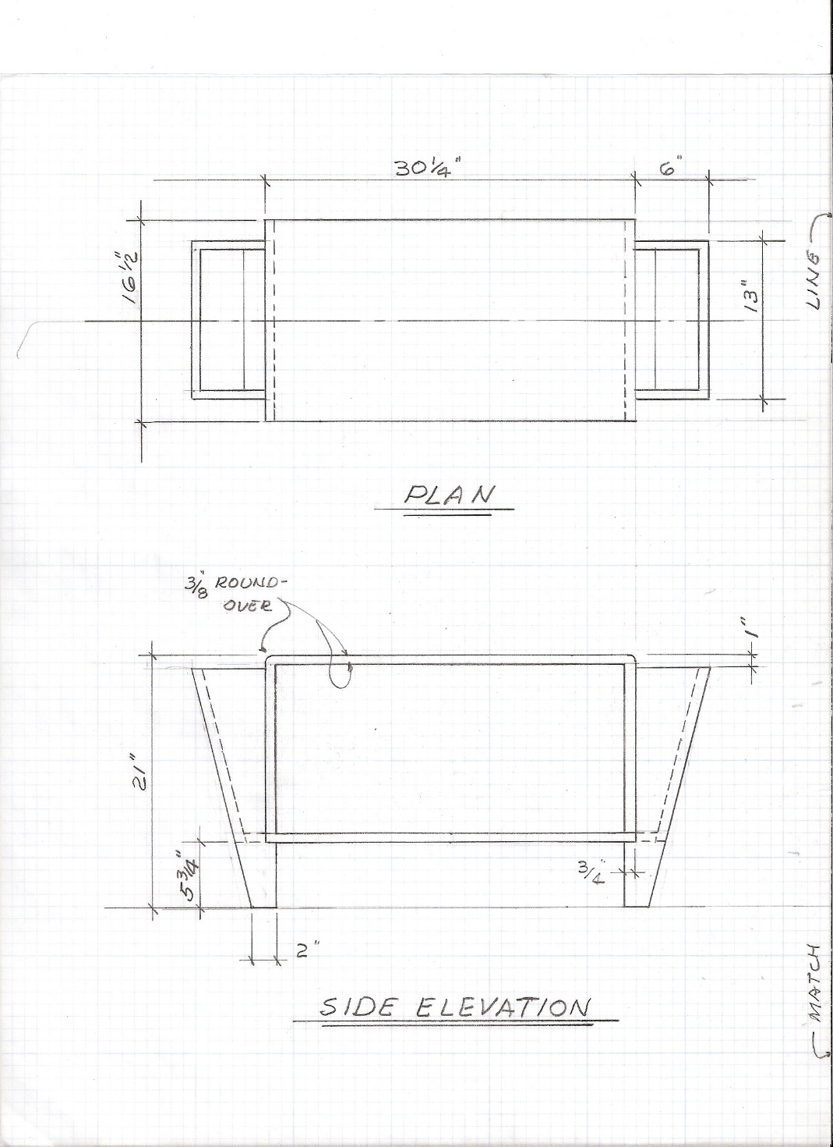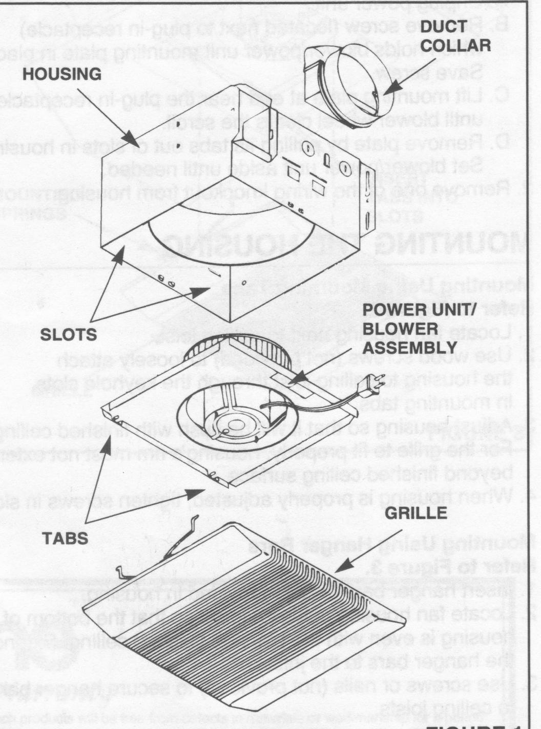

**🡹 Exploded view drawing of bathroom exhaust fan**

**🡹 Student CAD drawings**

**Top view**

**🡹 Hand-drawn engineering drawing of a bench 🡻**

**Side elevation**

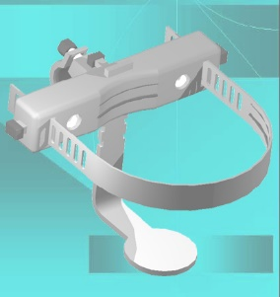

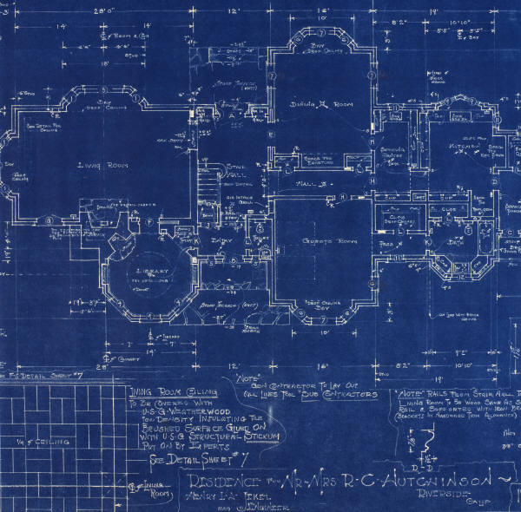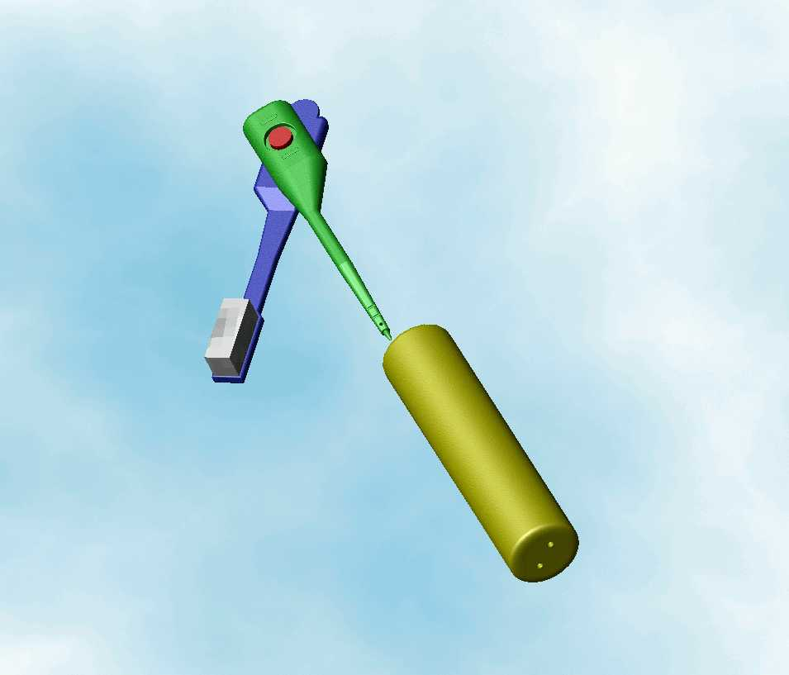

**Modern   
🡸 CAD drawings**

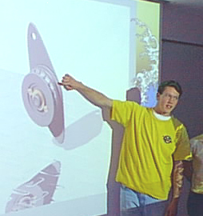

**Traditional blueprint   
of building design 🡺**