Agricultural Engineering: Cutting through Soil Activity – Name the Parts of a Plow Worksheet

Label the parts of the plow in the picture below:
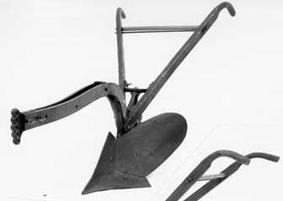

What part is this plow missing?
Draw your new and improved plow in the space below.

