Scientists investigate what is; they discover new knowledge by peering into the unknown... Engineers create what has not been; they create things that have never existed before...
— Joseph Bordogna, Deputy Director, National Science Foundation

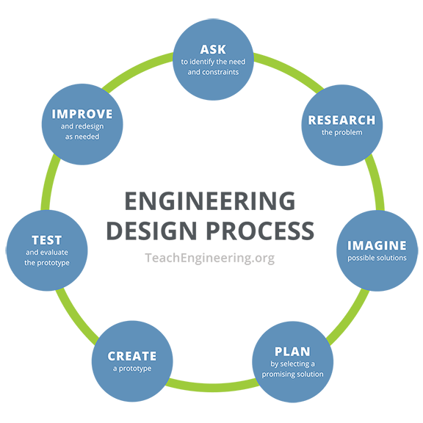

Every act of creation is first an act of destruction.
— Pablo Picasso

Imagination is more important than knowledge.
— Albert Einstein

Brainstorming Guidelines
No negative comments allowed.
Encourage wild ideas.
Record all ideas.
Build on the ideas of others. Stay focused on the topic.
Allow only one conversation at a time.

Engineering Design Process: Time To Design Lesson, Hot Problem Solving Activity
— Design & Brainstorming Handout

