World Energy Consumption and Production Datasheet
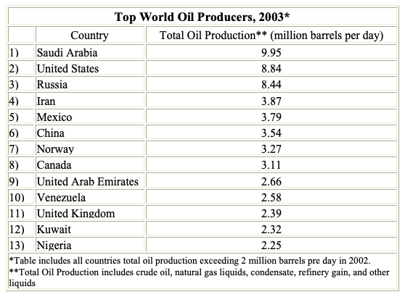

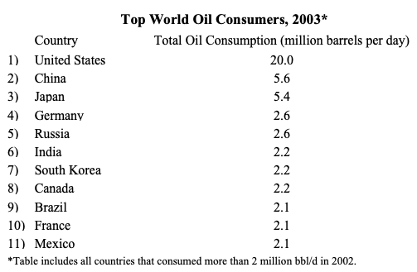

Source: Energy Information Administration, US Department of Energy,
http://www.eia.doe.gov/emeu/cabs/topworldtables1_2.html

