Coiling Snake Template

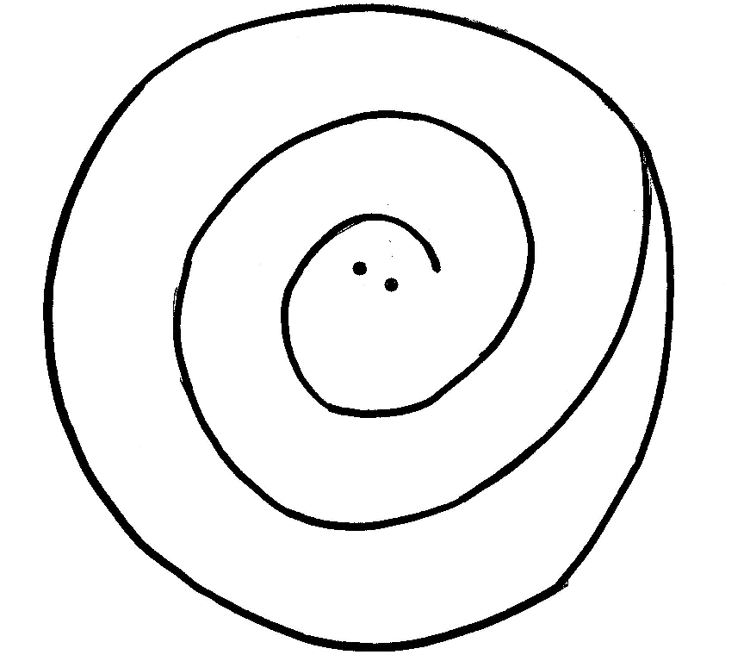

Carefully cut out your snake. Attach a thread or string to the head or tail for hanging.

