What Is a Circuit? Worksheet
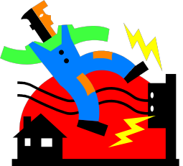
1. Vocabulary Words
Using complete sentences, write a definition for the following words:

Charge Current Voltage
Resistance

T

2. Drawing the Path of Electrons
Draw a picture of the circuit created in class. Label the light bulb, switch and
battery. Use arrows to show the direction the electrons flowed.

