Programmable Thermostat Energy Savings Worksheet
A family of five has just installed a programmable thermostat in their home. The first day that the new thermostat is installed, the outdoor temperature is very cold. Follow the steps below to determine the amount of money the family saves by using the thermostat.

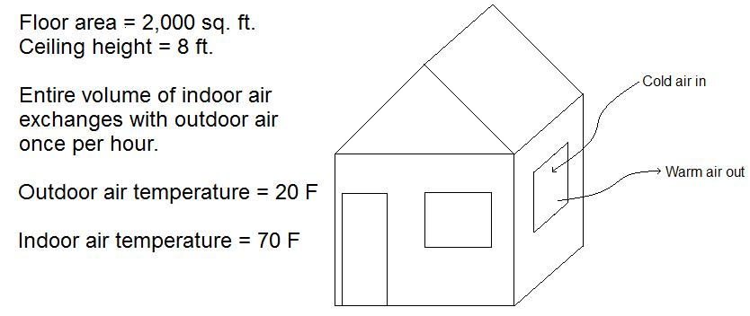

Step 1 – Determine the mass of air that must be heated each hour
The family lives in a 2,000 square foot home with 8-feet-high ceilings. Due to gaps around windows and doors, the use of kitchen and bathroom exhaust fans, and the opening and closing of the exterior doors, the entire volume of air within the home is exchanged with outdoor air once per hour (this also provides necessary ventilation for the family). The density of the air is 0.075 lb/ft³. What is the mass of the air that must be heated each hour?

$$m= Vd=Ahd=\left(2,000 {ft}^{2}\right)\left(8 ft\right)\left(0.075\frac{lb}{{ft}^{3}}\right)=1,200 lb$$
Where: m = mass of air
V = volume of house
d = density of air
A = floor area of house
h = ceiling height of house

Step 2 – Determine the energy needed to heat the home for one day
Before installing the programmable thermostat, the home’s indoor temperature was kept at 70˚F all day. Now the new thermostat is set at 70˚F from 6 am to 8 am and from 5 pm to 11 pm. When the family members are at work and school (from 8 am to 5 pm) and when they are sleeping (from 11 pm to 6 am), the thermostat is set at 60˚F. Determine how much energy is saved the first day. The specific heat of air is about 0.24 Btu/lb˚F (this means that 0.24 British thermal units are required to raise the temperature of one pound of air by one degree Fahrenheit; one Btu has about the same energy as the heat produced by burning a standard wooden match). Use the equation below.

$$Q=mC_{p}∆T$$

Where: Q = amount of heat required for one hour
m = mass of air that must be heated each hour
C_{p} = specific heat of air (0.24 Btu/lb˚F)
ΔT = temperature difference between the indoor and outdoor air

First, determine the amount of heat required for the home before the programmable thermostat was installed.

$Q=\left(1,200 lb\right)\left(0.24 \frac{Btu}{lb ℉}\right)\left(50℉\right)=14,400 Btu$

This is the amount of heat required per hour. Multiply this value by 24 to find the amount of heat required for the entire day.

$Q=14,400 Btu x 24=345,600 Btu$

Now determine the number of hours that the family keeps the house at 70˚F and 60˚F, respectively, during the day.

Number of hours the thermostat is set to 70˚F (6 am – 8 am & 5 pm – 11pm) = 8 hours
Number of hours the thermostat is set to 60˚F (8 am – 5 pm & 11 pm – 6 am) = 16 hours

From the above calculations, we already know how much heat is required per hour when the thermostat is set to 70˚F (14,400 Btu). Use the same equation to determine how much heat is needed when the thermostat is set to 60˚F.

$Q=\left(1,200 lb\right)\left(0.24 \frac{Btu}{lb ℉}\right)\left(40℉\right)=11,520 Btu$

Now find the total amount of heat required when the programmable thermostat is used.

$Q=14,400 Btu x 8 + 11,520 Btu x 16=299,520 Btu$

Finally, subtract the two calculated values to determine the amount of heat saved during the day.

$Q=345,600 Btu-299,520 Btu=46,080 Btu$

Step 3 – Calculate the amount of money saved by using the programmable thermostat
The family’s home uses an electric furnace. The electricity consumed by the furnace is measured in kilowatt-hours (kWh). To convert from Btu to kWh, divide by 3,414 (there are 3,414 Btu for one kWh). The family pays the electric company $0.12 per kWh. Determine how much money the family saves the first day the programmable thermostat is used.

Convert from Btu to kWh.

$$Q=\left(46,080 Btu\right)\left(\frac{1 kWh}{3,414 Btu}\right)=13.5 kWh$$

Calculate the cost of this energy.

$$Money saved=\left(13.5 kWh\right)\left(\frac{\$0.12}{kWh}\right)=\$1.62$$

Not only is the family saving money by using the programmable thermostat, they are also reducing their impact on the environment because most of our electricity is produced by burning fossil fuels (which releases carbon dioxide and pollutants into the air) or by using nuclear energy (which creates radioactive waste). List at least three more ways you can save energy at home.

