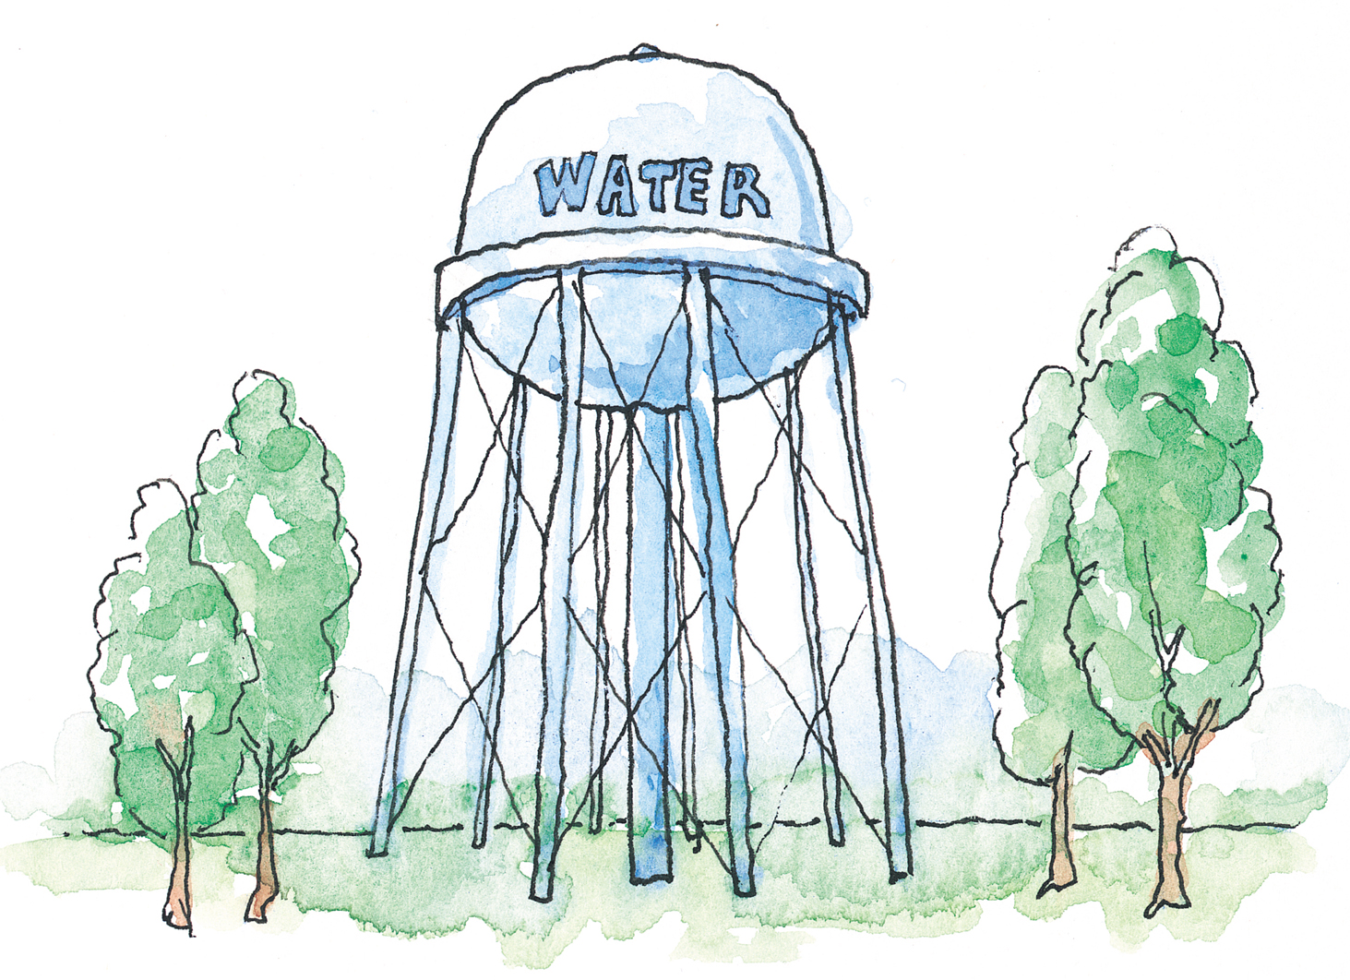
For Those at Home Activity –
Engineering Quiz

List seven different types of engineering:
, ,
, ,
, ,

List three types of engineers and give examples of their responsibilities:
, ,

What do you think is a good definition of engineering?

Which type of engineer works on making the environment (air and water) clean for people and animals?

Give an example of an engineering constraint:

Give an example of something that engineers designed that helps athletes to stay safe:

Why do engineers need to know about different kinds of materials?

Which kind of engineering most fascinates you? Why?

