**Step 1:**

j0383972[1]What is the height of the classroom door? ______

What is the width of one desk? **_________**

What is the length of string 1? _______

**Step 2:**

Did you and your secret partner get the same answers? __________

Why do engineers need to be able to measure accurately?

_______________________________________________________

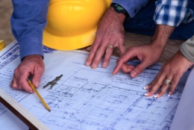

**Step 1:**

What is the height of your desk? ______

How tall is the teacher? **_________**

What is the *length, width and height* of book 1? ____x_____x_____

**Step 2:**

Did you and your secret partner get the same answers? __________

Why do engineers need to be able to measure accurately?

_______________________________________________________

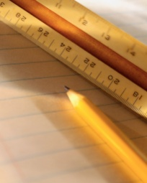

**Step 1:**

What is the width of the classroom door? ______

How long is one board eraser? **_________**

What is the *length, width and height* of book 2? ____x_____x_____

**Step 2:**

Did you and your secret partner get the same answers? __________

Why do engineers need to be able to measure accurately?

_____________________________________________________

**Step 1:**j0308088[1]

How tall is one whiteboard marker? ______

How wide is one window? **_________**

What is the *length, width and height* of book 2? ____x_____x_____

**Step 2:**

Did you and your secret partner get the same answers? __________

Why do engineers need to be able to measure accurately?

_______________________________________________________

**Step 1:**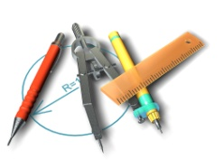

What is the height of your desk? ______

How wide is the hallway? **________________________**

What is the *length, width and height* of book 3? ____x_____x_____

**Step 2:**

Did you and your secret partner get the same answers? __________

Why do engineers need to be able to measure accurately?

_______________________________________________________

**Step 1:**j0232723[1]

How wide is this piece of paper? ______

How tall is your chair? **_________**

What is the length of string 2? _______

**Step 2:**

Did you and your secret partner get the same answers? __________

Why do engineers need to be able to measure accurately?

_______________________________________________________

**Step 1:**

j0281037[1]What is the height of your desk? ______

How long is the entire whiteboard? **_________**

What is the length of string 3? _______

**Step 2:**

Did you and your secret partner get the same answers? __________

Why do engineers need to be able to measure accurately?

_______________________________________________________

**Step 1:**j0304643[1]

How wide is your classroom (front to back)? ______

How tall is the teacher? **_________**

What is the length of string 1? _______

**Step 2:**

Did you and your secret partner get the same answers? __________

Why do engineers need to be able to measure accurately?

_______________________________________________________

**Step 1:**

j0291940[1]How wide is your classroom door? ______

How wide is one window? **_________**

How tall is your desk? ______

**Step 2:**

Did you and your secret partner get the same answers? __________

Why do engineers need to be able to measure accurately?

______________________________________________________

**Step 1:**j0296051[1]

How tall is the teacher? ______

How tall is your chair? **_________**

How long is a board marker? **_________**

**Step 2:**

Did you and your secret partner get the same answers? __________

Why do engineers need to be able to measure accurately?

_______________________________________________________

j0325664[1]

**Step 1:**

How wide is one closet door? ______

What are the dimensions of book 1? **______x______x______**

How wide is the window? ______

**Step 2:**

Did you and your secret partner get the same answers? __________

Why do engineers need to be able to measure accurately?

_______________________________________________________

**Step 1:**

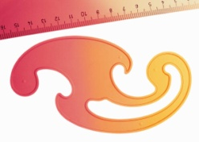

What is the width of one closet door? ______

How wide is your classroom (front to back)? **_________**

What is the length of string 2? _______

**Step 2:**

Did you and your secret partner get the same answers? __________

Why do engineers need to be able to measure accurately?

_______________________________________________________