Stack It Up!

Engineers always think about customer wishes when designing new things. We call these “customer requirements.”
Your leader has asked you to design a pyramid with a base (or bottom) level that measures 120 meters on
each side. Your leader is picky — she also wants the pyramid you design to be 72 meters high.
- The area of the base (or bottom layer) of your pyramid is calculated by multiplying the length of the pyramid base by the width of the pyramid base, measured in square meters.
Calculate the area of the base of your pyramid, using the base length and base width measurements in the drawing below. Please show your work.
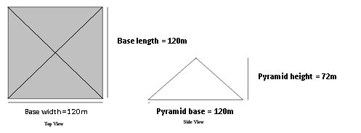

Area = Base length x Base width

My pyramid base area =

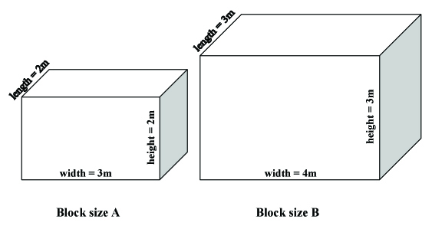
- Pyramids are created in many different styles, using different shapes and sizes of stones. Circle which stone block size you will use to create the bottom level, or base, of your pyramid:

- Calculate the area of the block of stone you have chosen, showing your work.
Block Area = Block length x Block width

My block area =

- To figure out how many blocks the stone cutters must remove from the quarry and transport to build the base of your pyramid, divide the area of the whole base level of your pyramid (your answer to question #1) by the area of one block of stone (your answer to question #3).
Number of blocks on base level = Base Area ÷ Block Area

My number of blocks on base level =

- The volume of an object is the amount of space it takes up. Find the volume of the stone block you have chosen (either Block size A or Block size B) to make the base of your pyramid. Please show your work.
Volume = Height x Width x Length

My stone block volume =

- Next, find the volume of the whole base layer of your pyramid by multiplying the area of your base level (your answer to question #1) by the height of the block size you have chosen. Show your work.
Volume of base layer = base area x block height

My pyramid’s base volume =

- A stacked pyramid is a lot like a geometric pyramid, but with smooth sides. You can use the approximate shape of a geometric pyramid to estimate the entire volume (including all layers) of your pyramid.

The volume of a geometric pyramid is found by this equation:

Example: Suppose you designed a pyramid to these requirements: pyramid base length = 100 meters, pyramid base width = 100 meters, pyramid height = 75 meters. You could calculate the approximate volume of the example pyramid to be:
meters³
Now calculate the volume of your pyramid, which has a base = 120 meters on each side, and height = 72 meters. Set up your equation and show your work.

My pyramid’s total volume =

- Let’s also calculate the total number of blocks stone workers must cut and transport to build all levels of your pyramid. To do this, divide the total estimated volume of your pyramid (answer to question #7) by the volume of one block of stone (answer to question #5).

My pyramid’s total volume =

Bonus Question: For even more challenge, compare this to the number of blocks stone cutters must cut for your pyramid if you chose the other block size in Question #2.

