Foam Core Tips
Foam core board consists of a piece of foam sandwiched between surface papers. The foam provides strength, and the paper provides surfaces for drawing and adhesion. Use the instructions below to learn how to use foam core safely to create cool objects.
Materials
- Xacto™ knife and blades
- ruler with a metal edge
- cutting surface such as a plastic board, kitchen cutting board or back of a newsprint pad.
Safety Tips
- When using a ruler to guide the knife blade, hold the edge of the ruler secure at a point on the ruler that is far away from the blade.
- Never kneel on the ruler when cutting.
- Wear closed-toed shoes in case the knife rolls off a table.
- When cutting, do NOT aim the knife blade toward your other hand or arm (see photo below).
- When cutting, DO keep your other hand above the direction of the knife blade (see photo below).
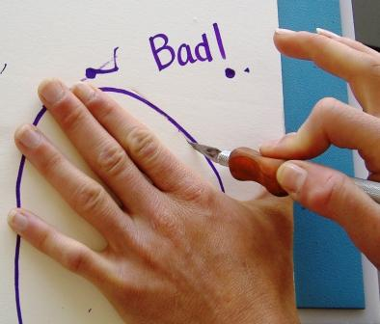
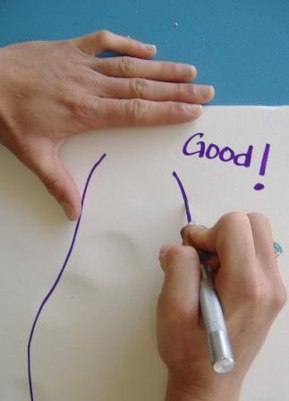

Cutting
Making one cut requires three strokes:
- First stroke scores surface paper.
- Second stroke cuts surface paper and foam.
- Third stroke cuts remaining foam and bottom paper.

Cool Shapes: Joints
2. Use the dull side of the knife to press along the cut to create a furrow.
3. “Close” the furrow by sealing with hot glue.
1. Cut down to, but not through the second sheet of surface paper. Bend the sheet back on itself.

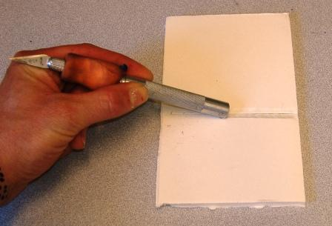
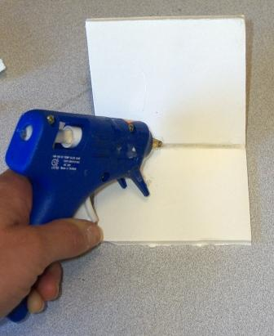
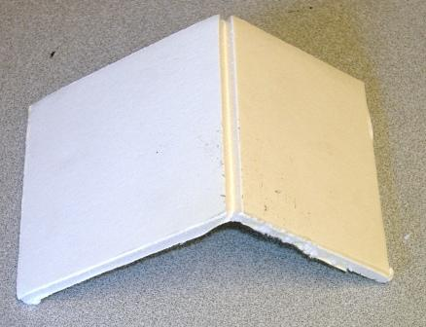

Cool Shapes: Simple Hinges
1. Cut through the top paper and foam; leave bottom paper uncut.
2. Bend foam.
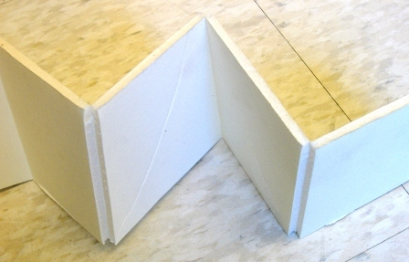
3. Shallower cuts results in a smaller hinge.

Cool Shapes: Roll-Top Hinges
1. Make a series of parallel cuts through the top paper and foam; leave bottom paper uncut.
2. Bend foam to create a curve.
3. Parallel cuts closer together result in a tighter curve.
