ICE, EV & Air Quality Connections Worksheet (3-5)
Do internal combustion engines (ICE) and electric vehicles (EV) affect our air?

Together, we are going to find out:
- Does vehicle transportation affect air quality?
- What type of air pollution comes from vehicles?
- How does air pollution affect our health?
- Can certain vehicles help make the air cleaner (healthy)?

1. Watch the video about vehicles and air pollution. Write or draw what you observe:
Class Reflection: How do vehicles affect how healthy the air is? What solutions do you think could help with reducing air pollution from vehicles? Share your thoughts as a class.

2. Let’s find out about two types of air pollution that comes from vehicles.
Particulate Matter (PM)
Particulate Matter, also called PM, is a type of air pollution that is released from emissions, including vehicle exhaust. Let’s learn more about PM air pollution in this video.
Particulate Matter is a pollutant made up of very tiny particles and droplets that float in the air.
- PM comes from natural sources like dirt, dust, and wildfire smoke.
- PM comes from human-made sources like soot from burning fuels for energy and heat.
- PM can make the air hazy.
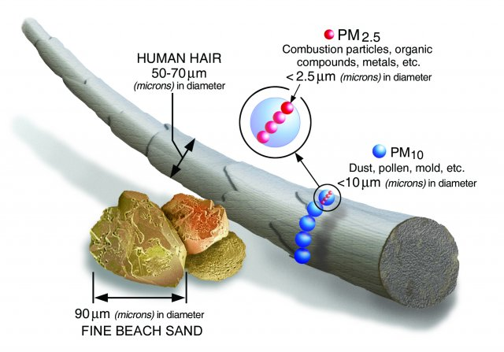
Look at the image of the size of two types of particulate matter, PM 2.5 and PM 10, compared to other objects.
- How does the size of PM 2.5 compare to PM 10?

- What do you notice about the size of PM 2.5 and PM 10 compared to the size of a human hair and a grain of sand?

2. Let’s find out about one type of air pollution that comes from vehicles.
Ground-Level Ozone
Ground-level ozone is a type of air pollution that is formed from emissions released into the atmosphere from burning fossil fuels for energy. Let’s learn more about Ozone air pollution in this video.
Ozone: Good Up High, Bad Nearby!
- Ozone is an invisible gas, so a clear, blue sky can still have high ozone pollution.
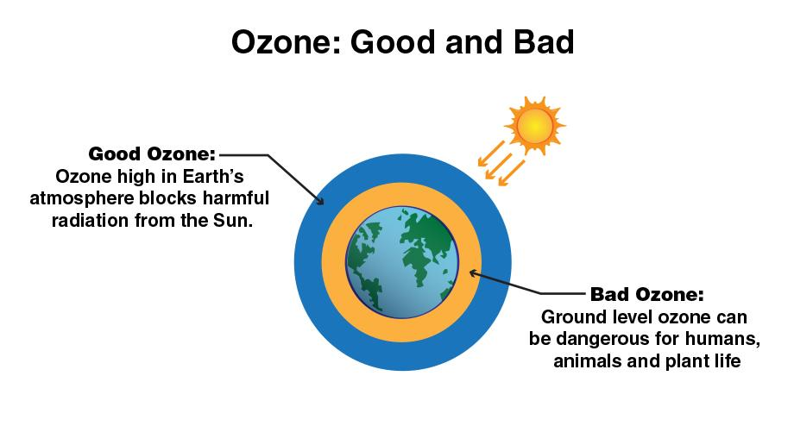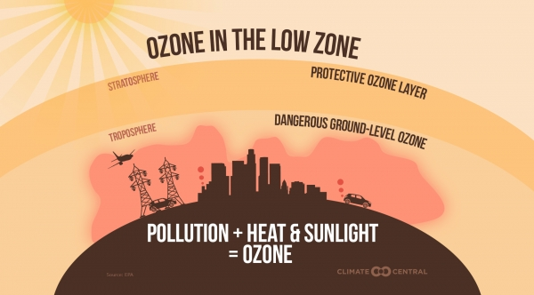
- Look at the two images. With a partner, discuss the similarities and differences of ozone in the atmosphere. Next, share observations as a class.
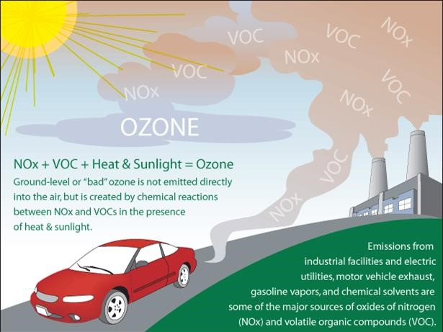
- Label the image with the correct terms to explain how ozone is made.
Word bank: emissions, warm air, sunlight, ground-level ozone

3. How does air pollution affect our health?
Draw a line to match the words and pictures to explain how breathing PM affects our health:
Health Effects of Breathing PM:  - Premature death in people with heart or lung disease  - Non-fatal heart attacks  - Irregular heartbeat  - Aggravated asthma  - Decreased lung function  - Increased respiratory symptoms, such as irritation of the airways, coughing or difficulty breathing. | Draw an image of one health effect of breathing PM:

3. How does air pollution affect our health?
Draw a line to match the words and pictures to explain how breathing Ozone affects our health:
Health Effects of Breathing Ozone:  - Cause coughing and sore or scratchy throat.  - Make it more difficult to breathe deeply and vigorously and cause pain when taking a deep breath.  - Inflame and damage the airways.  - Make the lungs more susceptible to infection.  - Aggravate lung diseases such as asthma, emphysema, and chronic bronchitis.  - Increase the frequency of asthma attacks. | Draw an image of one health effect of breathing Ozone:

4. Let’s figure out how ICE vehicles and electric vehicles work.
Now, let’s put together what we now know about PM air pollution and its health effects to learn how different types of vehicles affect how clean the air is.
- First, watch the video about how an ICE (internal combustion engine) vehicle works.
- Now, watch the video about how an electric vehicle (EV) works.
How are electric vehicles and ICE vehicles the same? Draw or write your answer:

How are electric vehicles and ICE vehicles different? Draw or write your answer:

Class Reflection: Share your thoughts on the following questions as a class:
- Is clean air important? Explain your reasoning.
- Do ICE or electric vehicles make our air dirtier? Explain with evidence.
- Do ICE or electric vehicles make our air cleaner? Explain with evidence.

