Mechanics of Muscle Motion
One of the fundamental principles in mechanics is the concept of torque. Torque is a twisting effort applied to an object that tends to make the object turn about its axis of rotation. This twisting force, also known as a moment to engineers, is produced when a force is applied to an object away from the axis or joint. For example, when we apply a force at the handle of a door, it rotates about its hinges and opens. This is similar to our muscles, which contract and produce force acting on our bones in order to rotate our body parts about a joint.
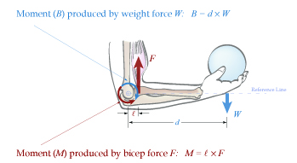
A moment is the product of a force and the perpendicular distance to its turning axis. For an object to remain in equilibrium (no angular motion), the moments about the axis must be equal. Engineers use a free body diagram, as shown below, to illustrate how the ball and the bicep muscle produce forces that tend to rotate the forearm about the elbow joint. These forces produce moments about the joint that can be written mathematically to describe the motion of the arm.
TeachEngineering.org – Free STEM Curriculum for K-12

The moment (M) produced by the bicep muscle must be equal to the moment (B) produced by the ball. Note: For simplicity, we assume that forces act perpendicular to the reference line and the weight of the arm is negligible.
