Human Ear Anatomy
- pinna
- lobule (ear lobe)
- external auditory (ear) canal
- temporal bone
- tympanic membrane (eardrum)
- malleus (hammer)
- incus (anvil)
- stapes (stirrup)
- semicircular canals
- vestibular cochlear nerve
- cochlea

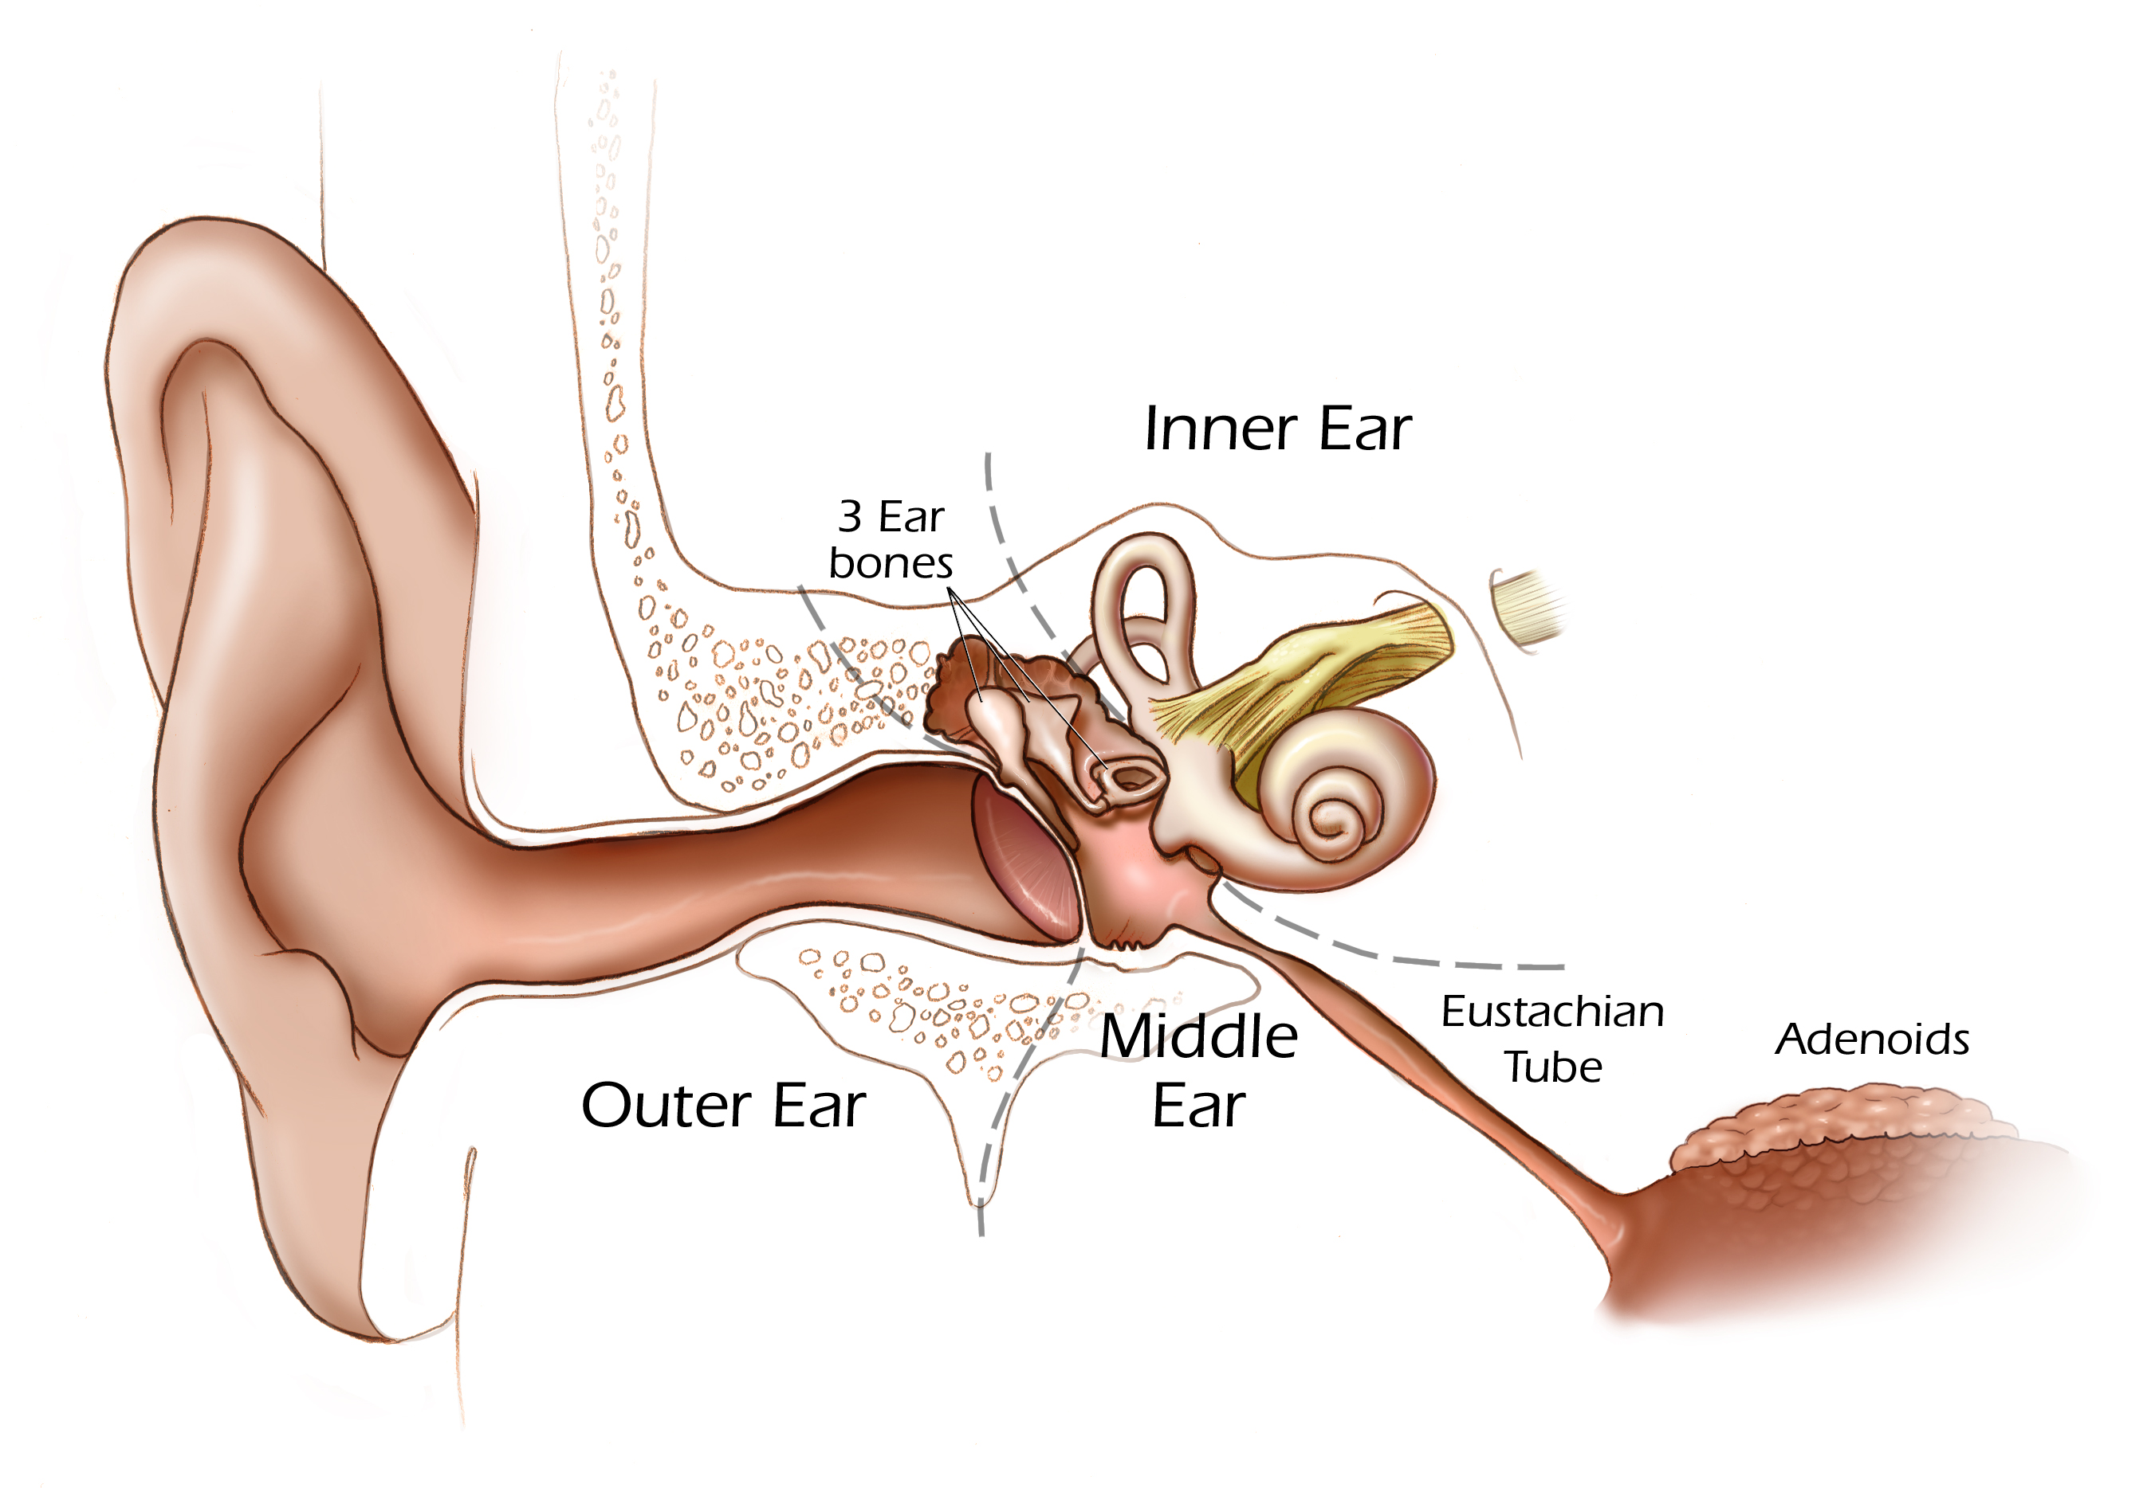
1
6
7
occicles
8
5
9
10
TeachEngineering.org – Free STEM Curriculum for K-12
4

11

3

2

Image source: National Institutes of Health, http://media.nih.gov/imagebank/display.aspx?ID=410
Human Ear Anatomy
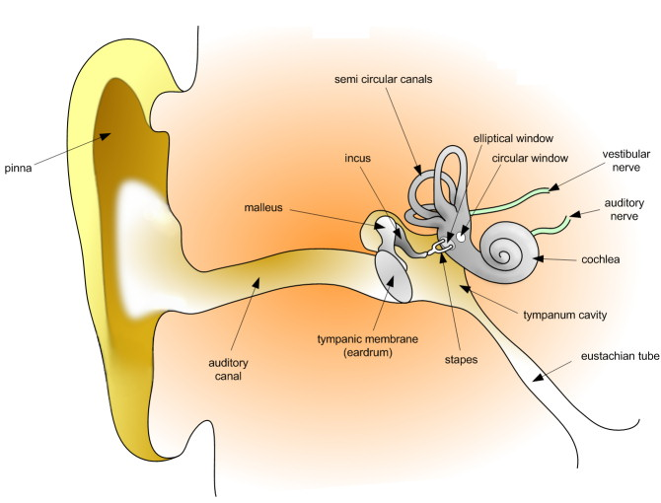

Image source: Dan Pickard, Wikimedia Commons, (public domain image) http://commons.wikimedia.org/wiki/File:HumanEar.jpg

