Force and Pressure Quiz
- Which would exert a higher force on a scale: A grown elephant or a baby elephant? Why?
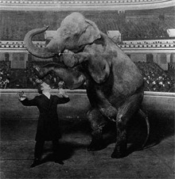

TeachEngineering.org – Free STEM Curriculum for K-12

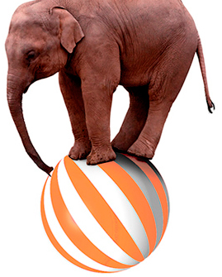
- Would an elephant standing on one leg exert a higher force on a scale than an elephant standing on four legs? Why?

- Would an elephant standing on one leg exert a higher pressure on the scale than an elephant standing on all four legs?

