Angles and Reflections Worksheet Answer Key
Answers 1, 2, 3, 4, 5 are shown below. Angles 1, 2 and 3 are acute angles; 4 and 5 are obtuse.
Angles that are less than 90 degrees (<90°) are called: _______ acute angles _______
Angles that are greater than 90 degrees (>90°) are called: ____ obtuse angles ______
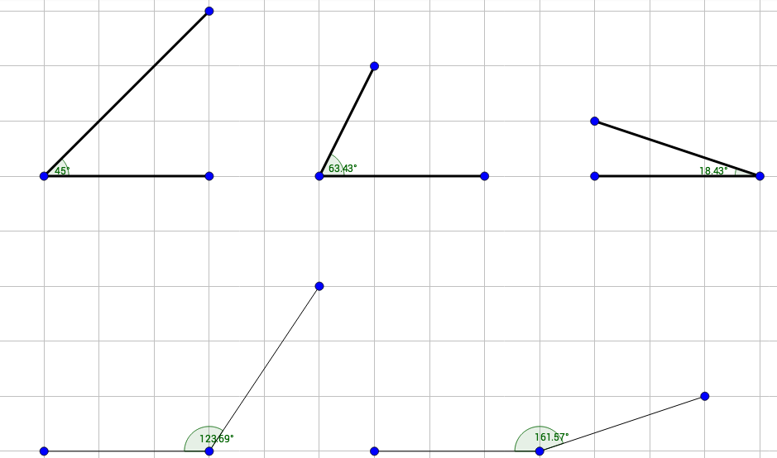
TeachEngineering.org – Free STEM Curriculum for K-12
Answers 6, 7, 8, 9, 10 are shown below.
