Lesson Worksheet
Let’s think like civil engineers and apply our knowledge of geometric shapes to the design of trusses.
Two-Dimensional Modeling
- What polygons are shown below?

TeachEngineering.org – Free STEM Curriculum for K-12

- Now imagine these polygons are standing upright with weight on them,
as shown by the force arrows below.

- Under this load, where would the shapes collapse?
Place stars where the polygons are likely to undergo failure (collapse).
Draw dashed lines to represent the deformed members. Explain your reasoning.

- If you were going to add support members to these shapes to keep them from collapsing, where would you put those? Draw them as dotted lines on the shapes above.

Three-Dimensional Modeling
Now let’s test how two prisms would change under a compressive load in a three-dimensional space instead of a two-dimensional space. You are given a cube and a triangular prism, below, to test.
- How would these square and triangular prisms deform under loads?
Draw dashed lines to represent the deformed shapes.

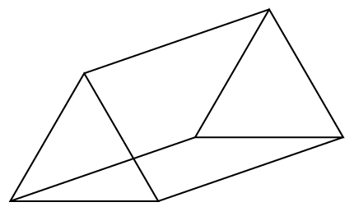

- If you were to add structural members to strengthen the shapes, where would you add them?
Draw them as dotted lines on your shapes above.

- Use a ruler to draw a square and an equilateral triangle. Measure all the angles in both shapes.
Find the sum of the interior angles in the square and triangle. Write your answers below the shapes.

- Consider the front shapes of the deformed square and triangle (below). Measure all their interior angles.
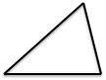
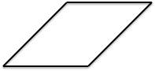

- How did each of the angles change in the deformed square and triangle?
What is the sum of the interior angles in the deformed square and triangle?

- Now draw the square in a way that will keep it from collapsing. You may add up to six members.

- Draw another polygon and add members in such a way that will keep it from collapsing.

- Why would engineers choose to design trusses from triangles rather than squares?

