Name: ___________________________________________________ Date: _________________________

Develop Your Own Rock Cycle Worksheet Answer Key

The rock cycle is the idea that the three main types of rock (sedimentary, metamorphic and igneous) undergo physical changes enabling each to change into any of the others. In other words, sedimentary can become metamorphic and/or igneous. Igneous can become sedimentary and/or metamorphic, and so forth.

The bullets below provide information on how each type of rock is formed.
- Any type of rock that undergoes heat and/or pressure can become metamorphic rock.
- Any type of rock that undergoes weathering and erosion turns into sediment.
- Any sediment that compacts or cements together can become sedimentary rock.
- Igneous rock is formed from cooling magma.
TeachEngineering.org – Free STEM Curriculum for K-12
- Magma is formed from melting of sedimentary, igneous and metamorphic rock.

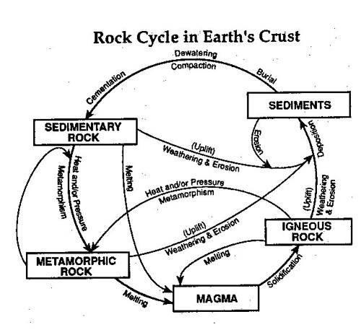
Using the above information, draw your own diagram to model the rock cycle. Your model should have five main categories – one for each of the types of rock and one for each of the intermediate stages (sediment and magma). Below is an example of the rock cycle. Forms of solutions may vary, but content should be the same.

