Pulley’ing Your Own Weight Worksheet

In the drawing of a fixed pulley, below, notice the location of the weight and applied force.

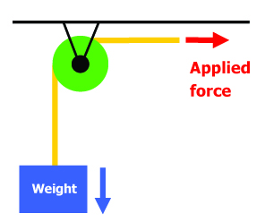

- Draw a movable pulley (string, pulley, weight) and label the forces (weight, applied force).

- Draw a two-pulley system with one movable pulley and one fixed pulley. Label the forces.

- What is the weight of the object you will lift? Remember to indicate the units.

____________________

- How much force is required to life the object in each test case?
Read the spring scale and record in the table, below.

Object Being Weighed | Force Needed to Lift?
Object along
Object with fixed pulley
Object with movable pulley
Object with two-pulley system

- Write a paragraph comparing how much force is needed to raise the object in all four cases.
Your paragraph should be at least three sentences long.

