Pulley’ing Your Own Weight Worksheet Answers

In the drawing of a fixed pulley, below, notice the location of the weight and applied force.

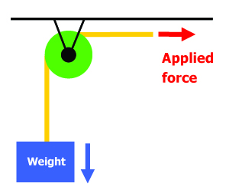

- Draw a movable pulley (string, pulley, weight) and label the forces (weight, applied force).
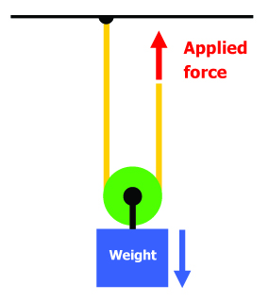

- Draw a two-pulley system with one movable pulley and one fixed pulley. Label the forces.
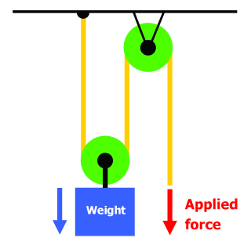

- What is the weight of the object you will lift? Remember to indicate the units.

____________________

- How much force is required to life the object in each test case?
Read the spring scale and record in the table, below.

Object Being Weighed | Force Needed to Lift?
Object along
Object with fixed pulley
Object with movable pulley
Object with two-pulley system

- Write a paragraph comparing how much force is needed to raise the object in all four cases.
Your paragraph should be at least three sentences long.

Students should notice that the force needed to move the object decreases when more pulleys are added.

