**Solar System Map**

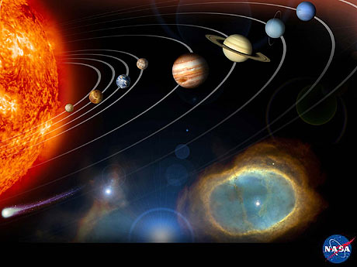

**Source:** NASA, <http://photojournal.jpl.nasa.gov/index.html>

Sun – Mercury – Venus – Earth – Mars – Jupiter – Saturn – Uranus – Neptune