Transparency #2: Gaspra Asteroid
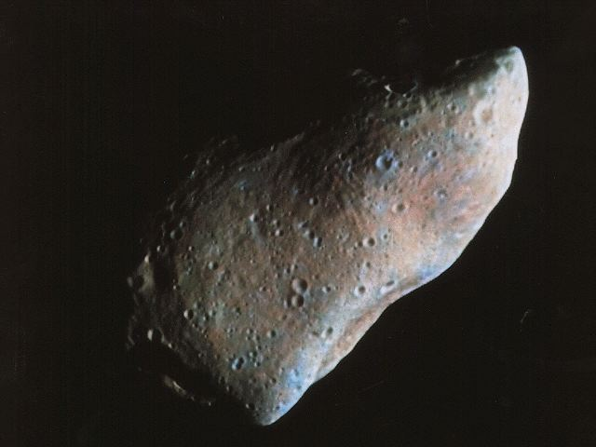

This asteroid, known as Gaspra, is 17 km (or, more than 10.5 miles) across. The circular marks you see on it are craters from previous collisions with other asteroids.

