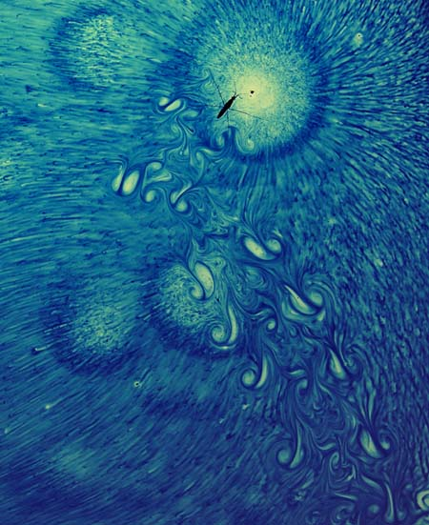

**A water bug trail left on a dyed surface.**

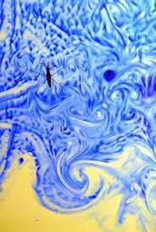

**A water bug on dyed water.**