Robots on Ice Student Worksheet Answer Key
Part A: Probing Questions about Space
Before beginning the lesson, think about the following two questions. Jot down your ideas and get ready to share.
1. Do you think life exists in outer space?
Student opinions will vary.
2. Have scientists and engineers found life in outer space? What clues would we look for?
No, but many are hopeful that with ever-evolving technology, we have a better chance of finding life. Researchers first look for water, but also chemical elements like carbon, and energy sources.
Part B: AEIOU Reflection
After slide 7, reflect on what you have just learned.
Then fill in a word or sentence that represents each letter, AEIOU.
Responses will vary; they reveal what individual students are thinking at this point in the lesson.
Part C: Ready for Europa?
At lesson end, answer the questions below.
1. Compare the characteristics of Earth and Europa using a Venn diagram.
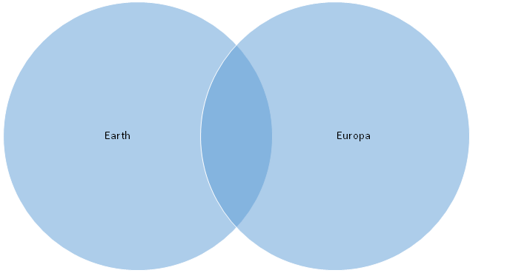
Note: Many possible correct responses exist to this question, but expect students to use information learned from the slide presentation to answer the question. Some possible example answers are provided, but be prepared for many more ideas.
Similarities: Europa and Earth have similar compositions. Researchers believe Europa has oxygen in its atmosphere and Earth’s atmosphere is about 20% oxygen. Scientists believe Europa has an iron core like the Earth. They also believe that it contains water and ice, like the Earth.
Differences: The Earth is different because it has land on its surface, not just ice and glaciers. The Earth contains a variety of life, and while it is possible for Europa to have life, we do not know if that is the case just yet. Europa is much smaller than Earth; it is smaller than our moon. Europa is a moon, not a planet like Earth. It is believed that Europa contains more water than Earth.
2. Do you think we will find life on Europa? Explain.
Responses will vary, but for students who think life is present on Europa, expect them to point to the link between ice/water and life as a key condition for life as we know it.
3. While Icefin is an innovative robot, it still needs a lot of work before it is ready for a mission to Europa. What design challenges will engineers need to tackle before launch?
Many possible correct responses exist to this question; some example answers: The robot needs to travel a far distance in space; be able to withstand the strong radiation on Europa; be able to work autonomously without controlling communications from people on Earth; be able to drill through very thick ice to access the water.

