Linear Approximation Exit Ticket Answer Key

Exact student answers will vary. An example solution is provided.

I have several students who work in restaurants. The data in the table below shows how many hours they worked last week and how much money each one made, including tips.
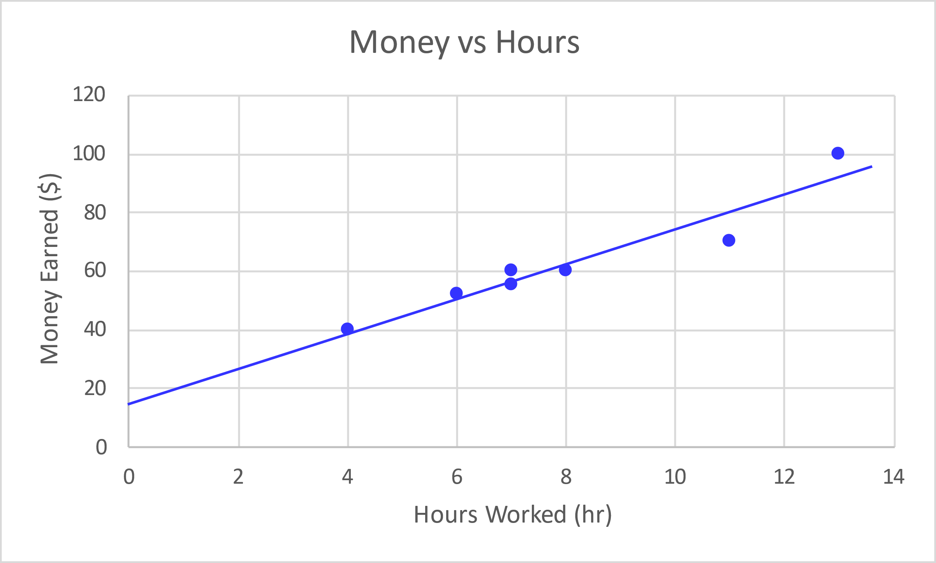
Hours | Money
7 | 55
4 | 40
11 | 70
8 | 60
6 | 52
13 | 100
7 | 60

Find the equation of a line that you think best follows the data. Show your work or include a justification of the values for your equation.
Students should plot the data and draw a line of best fit. Check that students label the axes.
Select two points to find the slope: (6,50) and (11,80)
Slope = $\frac{y_{2}-y_{1}}{x_{2}-x_{1}}=\frac{80-50}{11-6}=6 { \$}/{hours per wk}$

Use the point (11,80) to find the y-intercept (b) in the equation $y=6x+b$
$80=6 \left(11\right)+b$ ; solving for b results in $b=14 \$$
Slope-intercept form equation: $y=6x+14$
Where y is the money students earned (in $) and x is the hours worked (per week).

Use your equation to determine how much you would expect someone who worked 15 hours to make. Show work.
Let $x=15 hours worked$
$$y=6 \left(15\right)+14=104 US \$$$

