Final Recommendations Post-Assessment
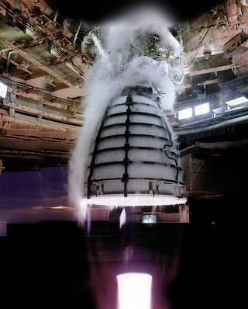
Instructions: Based on the data presented on the Class Data Table, write a letter to the SLS Deputy Program Manager, Ms. Jody Singer, explaining the material you recommend NASA use for the RS-25 engines and engine turbines. Use data to support your reasoning. In addition, begin your letter with an introduction of yourself and the purpose for writing this letter.

Dear Ms. Singer,
__________________________________________________________________________________________________________________________________________________________________________
_____________________________________________________________________________________________________________________________________________________________________________________________________________________________________________________________________________________________________________________________________________________________________________________________________________________________________________________________________________________________________________________________________________________________________________________________________________________________________________________________________________________________________________________________________________________________________________________________________________________________________________________________________________________________________________________________________________________________________________________________________________________________________________________________________________________________________________________________________________________________________________________________________________________________________________________________________________________________________________________________________________________________________________________________________________________________________________________________________________________________________
_____________________________________________________________________________________
Sincerely,

