Redox Reactions and Alternate Energy Solutions Handout
Design Problem: When water is separated into oxygen and hydrogen, energy is stored. When oxygen and hydrogen are recombined to make water, energy is released. The reaction of oxygen and hydrogen is very violent and wastes a lot of energy as heat. You will create a device that performs this redox reaction so that the energy can be harnessed in a more useful way. Then using this experience, reflect on decisions engineers must make regarding environmental impact and fuel cell design.
Materials:
- Brownlee electrolysis apparatus
- baking soda
- 2 platinum electrodes
- solar panel (or battery eliminator if indoors)
- multimeter (or voltage meter)
Procedure: Electrolysis of water
Lab Part 1:
- Place one of the tubes in the water so that the water covers the top of the tube.
- Using light pressure, secure a rubber stopper with an electrode in it inside the top of tube so that the water is contained inside the tube. Be careful not to break the tube when inserting the rubber stopper.
- Repeat this process with the other tube.
- Secure both tubes to the apparatus so they are held vertically about 2 cm above the bottom of the container.
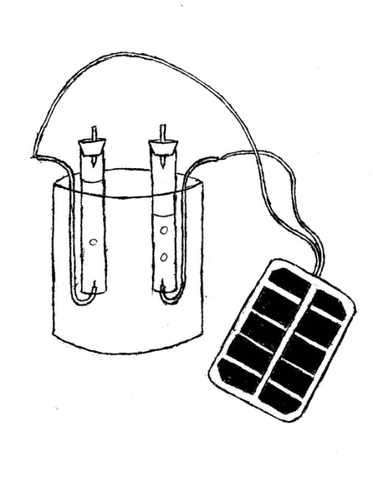
- Carefully add a small amount of baking soda to the water to serve as an electrolyte.
Figure 1
- Place one bent electrode at the bottom of each tube so the metal tip is pointing upward into the tube.
- Attach the positive lead of the solar panel to one electrode and attach the negative lead of the solar panel to the other electrode. (If done as an indoor experiment, use a battery eliminator instead of a solar panel).
- The apparatus should resemble Figure 1. When given permission by the teacher, carefully walk the apparatus outside so that the solar panel is in the sunlight.
- Let the system run until the electrode at the top of each tube is covered with gas, then detach the leads.
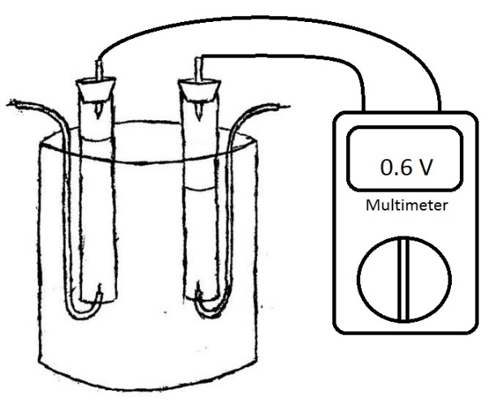
Lab Part 2:
Figure 2
- Place the voltage meter across the electrodes on the top of the tubes. Platinum works as a catalyst for the reaction; be sure that each electrode is completely covered in gas. Your apparatus should resemble Figure 2.
- With the multimeter attached to the electrodes, place the power cell in a location where it will not be disturbed. Mark the gas levels in each tube and check the tube in the morning.
Questions:
- Reflect on how much gas was produced in each tube. Which lead (positive or negative) produces hydrogen? Which produces oxygen? Explain how you know.
- What happens to the amount of gas in each tube after the fuel cell has been left on overnight?
- When hydrogen and water react they produce pure water. Explain the difference in energy transfer between the combustion of these substances verses the redox reaction. What are the advantages and disadvantages of using each energy type?
- Describe electrolysis of water as endothermic or exothermic. What type of energy was used to perform this electrolysis?
- Batteries “go dead” after all of the stored energy has been used. Explain what it means for a battery to “go dead.” Do batteries run out of fuel or materials as they release energy? Explain the process of charging and dying while reflecting on the principle of conservation of mass.
- Hydrogen fuel cells are considered “clean energy” because the product of the reaction is pure water. Consider how you produced hydrogen and oxygen, and how this process might differ on a large scale.
  - What effect would producing hydrogen on a large scale have on the environment?
  - Under what circumstances could hydrogen fuel NOT be considered clean energy?
- Oxygen is an extremely reactive gas. What would happen if a piece of iron were left in the oxygen collection container? What effect would this have on the cells’ ability to store and release energy? What decisions must an engineer make to make sure that a fuel source is “rechargeable”?
- Use your answer to question 6 to predict why older rechargeable batteries lose their ability to charge over time, especially if not completely discharged.
- Does the amount of gas in the tube affect how much voltage is produced? Explain your answer. Then explain why an engineer would choose to design a fuel cell with a larger gas reservoir.
- What engineering decisions could be made when designing the fuel cell to increase the rate at which energy is produced (how fast the reaction happens)?
- Compare and contrast how energy is released during the combustion of hydrogen (shown in the pre-lab demonstration) and the oxidation of hydrogen (when the fuel cell is used to create a voltage across the meter). How might each type of energy be harnessed to power a vehicle? What concerns should be taken into account when engineering a machine to harness energy from each type of reaction? You may need to do some research to answer this question.

