Mathematical Modeling Linear Approximations Handout Answer Key
Warm-up
Logistics engineers have a goal of optimizing the productivity and efficiency of their company. To do this, they measure all aspects of the company, including measuring employee productivity with the labor productivity equation:
The table below represents a manufacturer’s average employee input, hours worked in a week, and average employee output, total dollar value of goods produced in that week.
Hours Worked (per week) | Value of Goods Produced (in US $)
40 | 16200
43 | 17630
45 | 18675
48 | 19440
50 | 20050

1) Do you think this data follows a linear pattern? Explain.
Example answer: Yes, because the value of good increases as the hours worked increases. With every five hours increased, the value of good increases by about the same amount (~$2000).
2) What do you think the value of goods produced by an employee who works 55 hours in a week will be? Provide a justification for your answer.
Example answer: The employee who works 55 hours a week would provide an output of $21975.
From 40 to 45 hr/wk, the change in value of goods was 18675 - 16200 = $2475. From 45 to 50 hr/wk, the change in value of goods was 20050 – 18675 = $1375. So the change in value of goods from another increased 5 hrs might be the average of these two changes, (2475 + 1375) / 2 = $1925. So from 50 to 55 hr/wk, the value of goods might be 20050 + 1925 = $21975.
3) Do you think everyone in class will get the same answer that you got in #2? Explain.
Example answer: No, because the value of goods does not increase by the exact same amount with each increased hour worked.
Today you will investigate the idea of linear approximations. Often times in math class, the situations from a textbook follow a trend perfectly. Real-life mathematics often do not do this and require users to apply models that ‘fit’ a data set in order to make predictions about future data. This mathematical modeling is often used in engineering, such as by packaging engineers.
Your Task: Battle Creek Cereal has a variety of packaging sizes for their Crispy Puffs cereal. Below is a list of six current packages. Though they like their current packaging sizes, they want to expand their options. They need your help to create a model that they can use to create more packaging options.
- Data Collection is the first step in mathematical modeling. Sometimes the data is already collected, such as the table below, and sometimes the data has to be collected (we will explore this in another activity).
Packaging Cardboard (inches²) | Net Weight of Cereal (grams)
34 | 21
150 | 198
218 | 283
325 | 567
357 | 680
471 | 1020

- Graph a scatter plot of the above data to present to the executives of Battle Creek Cereal. This scatter plot will allow you to have a nice visual of how your data currently looks. Make sure to create labels so the executives can understand your graph!

Example shown below. Check that students label the axis and title their graph.

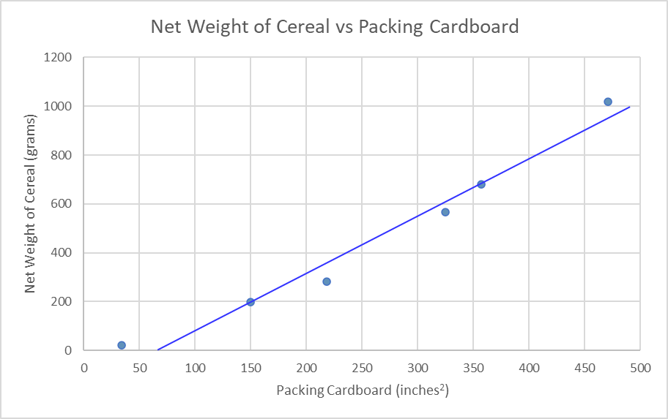
- Draw in a line-of-fit using a ruler that best represents your data. This line-of-fit should follow the general trend of the data. Make sure you know two distinct points that your line passes through.
**Hint: It is helpful to label these points with their coordinates.

Exact points students select may vary. Example points selected.

Point 1 is (150,198)
Point 2 is (357,680)

- Create a model, typically an equation, for the executives to use to predict the net weight of cereal based on the amount of cardboard used for the package. We can use our two points to make a slope-intercept form equation!

Example answer:

Slope = $\frac{y_{2}-y_{1}}{x_{2}-x_{1}}=\frac{680-198}{357-150}=2.33 {grams}/{{inches}^{2}}$
x-intercept looks like it is at (60,0). To find the y-intercept (b), use $y=2.33x+b$
$0=2.33 \left(60\right)+b$ ; solving for b results in $b=-140 grams$
Slope-intercept form equation: $y=2.33 x-140$

- Define the variables in your model so the executives understand what the model represents.

The variable x represents____the size of the packaging cardboard in inches²_______.

The variable y represents_____the net weight of cereal in grams_______.

- Evaluate using your model to give a prediction to the executives how much cereal a new experimental “green” package that uses 260 inches² of cardboard is expected to hold.
Example answer:
Let $x=260 {inches}^{2}$
$$y=2.33 \left(260\right)-140= 466 grams$$
The executives also posed the following questions and want to see if your model can be used to give an answer:
- The executives want to introduce a new super-sized box for large families to uses 600 inches² of cardboard. How much cereal would this box be able to hold?
Example answer:
Let $x=400 {inches}^{2}$
$$y=2.33 \left(400\right)-140= 792 grams$$

- The executives found that a typical serving of cereal is 55 grams and they want this size to replace the current personal package size of 21 grams. How much cardboard would be needed to package 55 grams?
Example answer:
Let $y=55 grams$ and then solve the model for x.
$55=2.33 x-140$ ; solving for x gives $x=84 {inches}^{2}$

Wrapping-up
In the warm-up, you wrote down your thoughts on the manufacturing problem. After learning about linear approximation, try to reconsider the questions below.
The table below represents a manufacturer’s average employee input, hours worked in a week, and average employee output, total dollar value of goods produced in that week.
Hours Worked (per week) | Value of Goods Produced (in US $)
40 | 16200
43 | 17630
45 | 18675
48 | 19440
50 | 20050

1) Do you think this data follows a linear pattern? Explain.
Example answer: The data appear to follow a linear pattern. The value of goods seems to increase by roughly the $2000 per each increase of 5 hours worked.
2) What do you think the value of goods produced by an employee who works 55 hours in a week will be? Provide a justification for your answer.
Exact answers may vary. Check that students graph the data to visualize it, draw a line of best fit, and develop an equation for the line that they can use to model the data.
Example answer below.
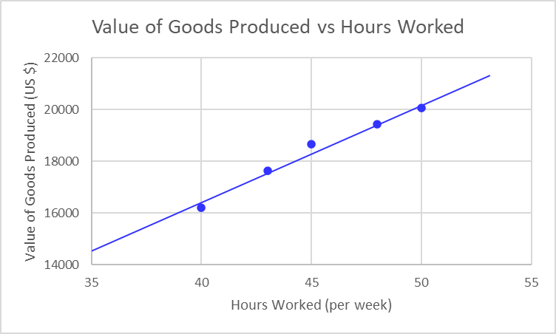

Select two points to find the slope: (35,14500) and (48,19440).
Slope = $\frac{y_{2}-y_{1}}{x_{2}-x_{1}}=\frac{19440-14500}{48-35}=380 {US \$}/{hours per wk}$
Use the point (48,19440) to find the y-intercept (b) in the equation $y=380x+b$
$19440=380 \left(48\right)+b$ ; solving for b results in $b=1200 US \$$
Slope-intercept form equation: $y=380x+1200$
Where y is the Value of Goods Produced (in US $) and x is the hours worked (per week)

Now use the model equation to find the value of goods produced by an employee who works 55 hours in a week.
Let $x=55 hours per wk$
$$y=380 \left(55\right)+1200=22100 US \$$$

3) Do you think everyone in class will get the same answer that you got in #2? Explain.
Example answer: No, because people may have drawn different lines of best fit. And my estimate of two points to calculate the slope might be different from other people’s.

