Speed & Momentum Crash Quiz
- Fill in the flow chart diagram below with the steps of the engineering design process.
Choose from the options provided below the diagram.
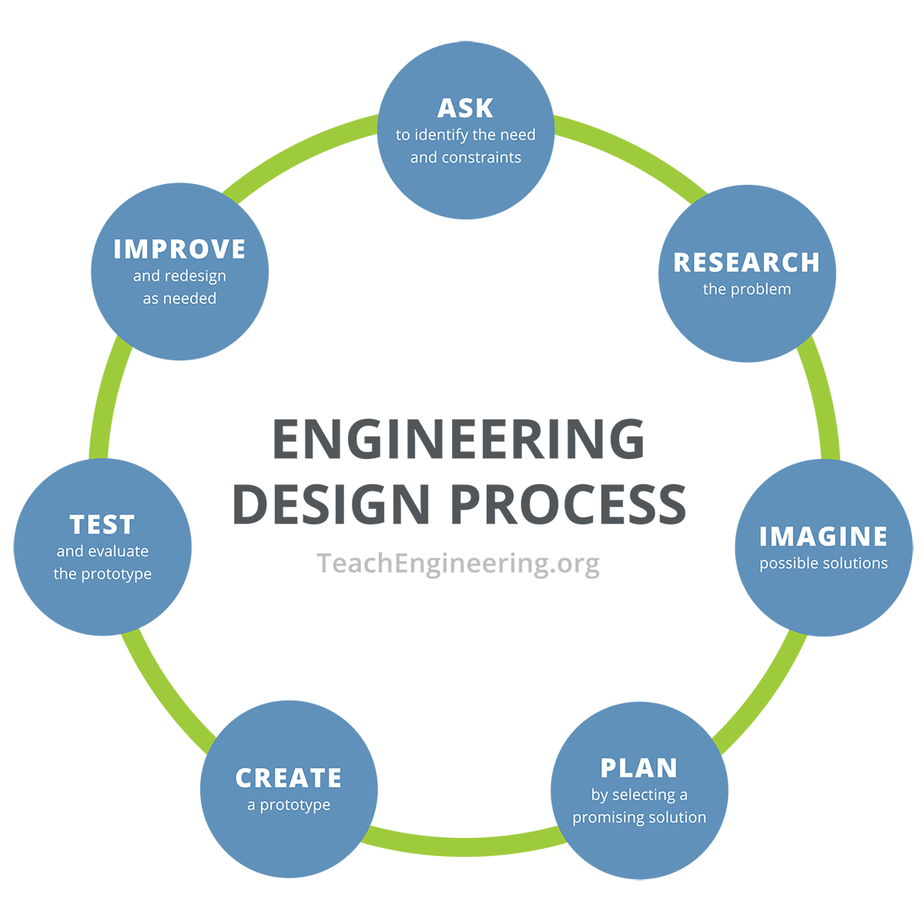

- Ask to identify needs and constraints
- Imagine possible solutions
- Improve and redesign as needed
- Research the problem
- Create a prototype
- Test and evaluate the prototype
- Plan by selecting a promising solution

- Describe momentum.

- Describe the relationship between mass and momentum.

- Explain the importance of using the steps of the engineering design process to solve real-world problems related to momentum and collisions.

