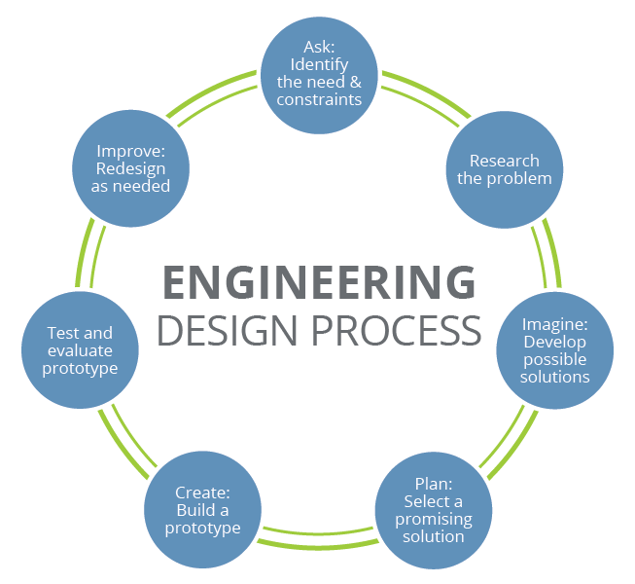
Paddle Testing Handout
Design Challenge
You have been tasked with creating a new ping-pong paddle design for the 2020 Olympics. You and your group need to study the materials and determine which ones will create the most effective paddle design. After creating your prototype, your group will perform several tests to compare your paddle to a store-bought paddle for ball control, comfort, and durability. After comparing your design to a store-bought paddle, you will have the opportunity to redesign your paddle. Your paddle must have a core, a coating to make the core sturdy, and a covering over the blade. Good luck!

Test
Test both paddles for ball control, energy absorbed by the paddle, paddle wear & tear, and handle comfort.

 | Group’s Paddle |  |  |  | Premade Paddle
 | 1 | 2 | 3 | Average | 1 | 2 | 3 | Average
Test 1: Hit the ball in the air for 30 seconds.
Test 2: Lay the paddle on the ground, drop the ball from 3 feet, and measure how high it bounces.
Paddle wear & tear: describe any wear and tear on your paddle. Compare before & after pictures.
Paddle comfort: describe how the paddle felt in your hand. Explain how you might make it more comfortable.

Product Reviews
Use the Venn diagram to start comparing and contrasting the two paddles. Remember that similar qualities go in the center.

Product Redesign
After testing, how would you change your paddle design?

Product Review Script
I rate the ping pong paddle at ____/5 stars because…
What I liked about the paddle was…
What I would change about the paddle was…

Activity Extension
What is the area of the blade of the paddle you created? What is the total area of all materials needed for you ping pong paddle design?

Activity Extension
With the budget found on the materials and budget list, you need to build and design your paddle again. Which materials will you choose to create the best paddle to stay within budget?

