Pre/Post-Assessment Answer Key
- What process do engineers use solve problems?
The Engineering Design Process (EDP).
- Match the steps of the EDP to the letter where they belong.
__B__ Brainstorm solutions
__F__ Communicate results
__A__ Define requirements & constraints
__D__ Design & build prototype
__E__ Evaluate & test prototype
__C__ Evaluate solutions
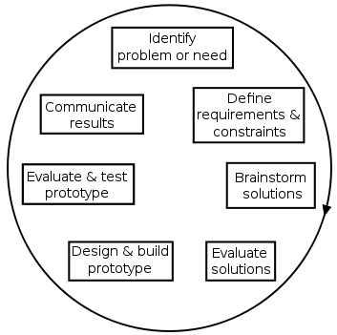
A
B
C
D
E
F

