Pre/Post-Assessment
- What process do engineers use solve problems?
- Match the steps of the EDP to the letter where they belong.
_____ Brainstorm solutions
_____ Communicate results
_____ Define requirements & constraints
_____ Design & build prototype
_____ Evaluate & test prototype
_____ Evaluate solutions
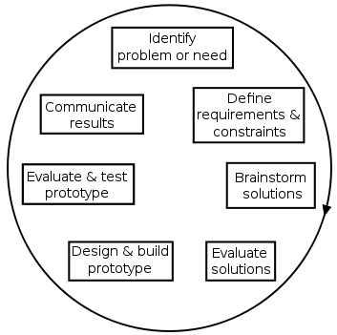
A
B
C
D
E
F

