Panoptes and the Bionic Eye Worksheet
Vocabulary
Word | Definition | Notes
retina | The photo-sensitive region of the eye.
cerebral cortex | The outermost layer of the brain, which is responsible for high-level sensory processing and integration (and more).
visual field | The space visible to a person or other organism at a given time.
visual cortex | The area of the brain that is responsible for processing visual data.
primary visual cortex (V1) | The first area in the visual cortex to receive visual information from the eye.
visual pathway | The anatomical route that visual information takes from the eye through the central nervous system.
neuron | The primary cell of the central nervous system.
histogram | A graphical representation of quantities in different categories.
receptive field | A sub-region of the visual field that causes a reliable response from a given part of the visual pathway.

Blind Spot Questions
- Can you find your blind spots?

- Why don’t you notice a “hole” in your vision all the time? How do you think your brain hides your blind spots?

Running the Experiment: Collecting Data
Steps
Find out how Panoptes sees the outside world by flashing the light in a regular pattern.
Quickly, make three or four passes of the zig-zag pattern shown below.
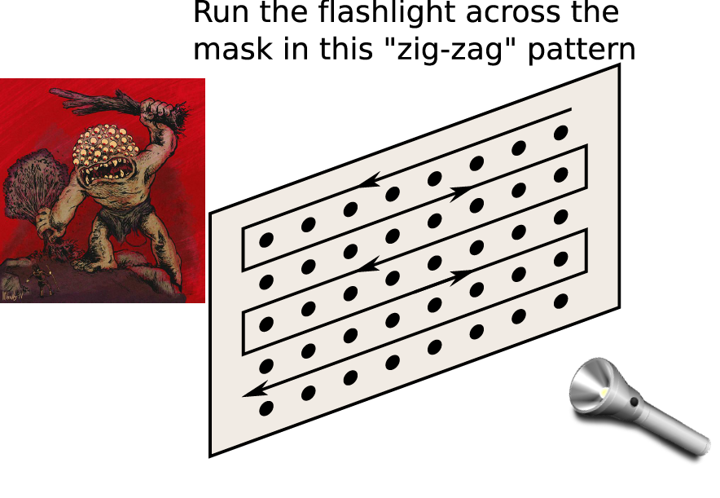
Stim expert:
- Hold the flashlight right up to the mask.
- Point the light straight ahead through the hole, and drag it along the path.
- Count off the holes as you pass them by.
Recording expert:
- Press the right arrow button on the NXT once each time the Stim expert counts.
Tips:
- Have the person scanning the light count off each hole just before shining light through it.
- The person marking time must mark every event just once.
- The amount of time the NXT can record is short, so move through the grid quickly, but shine through each hole for a full count.

End of Stage 1

Making Histograms
Often, “raw” data is not as clear as it could be. Summarize the spike counts caused by the randomized conditions below by making a bar chart (histogram) of the counts according to condition.

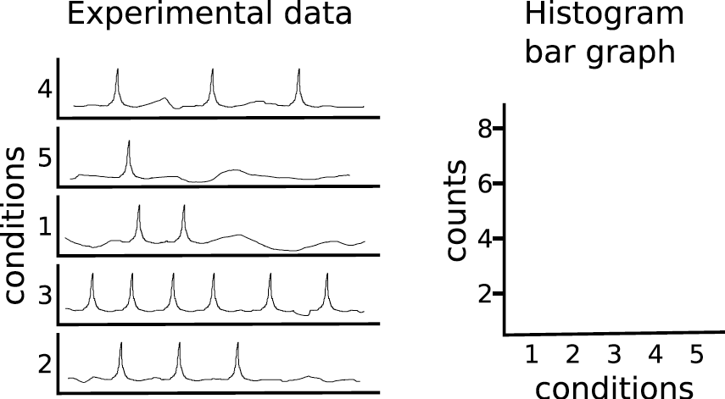

Organizing the Results
Notice that we started the zig-zag pattern at the top right—from our perspective. But from the perspective of Pantopes, it is the top-left. The visual field chart on the next page begins numbering the locations from the top-left.
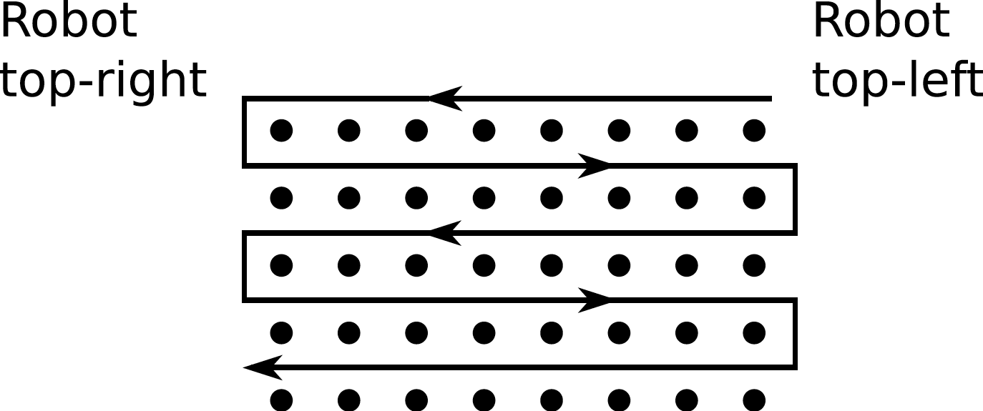

Visual Field Chart
