MINDSTORMS® EV3 Sensor Assembly Instructions
Directions
The LEGO® MINDSTORMS® EV3 Ultrasonic Sensor (Port 4) should be placed on the floor, underneath the boom, in such a way that the weight cup suspends over it at all times (see Figure 2 below) by approximately 5-in. from the bottom of the cup (this yields the best measurement results). This means that depending on the boom being measured, you must fix the string (or the sensor) to allow this distance to remain constant. The attached EV3 program (DeflectionMesure.rbt) can be modified in the following ways:
- Deflection range – You may modify the deflection measuring range (2cm default) by switching the constant called 2.
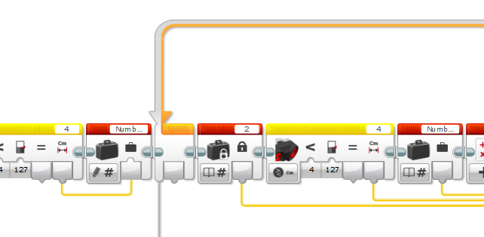
Figure 1. Modifying Deflection Limit
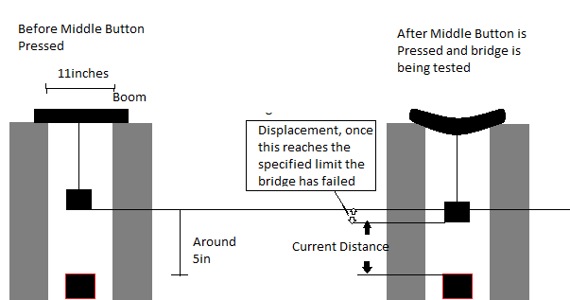
- Setting the distance between cup and sensor – When the program is activated, it waits for you to press the middle orange square button on the EV3. Once this button is pressed, it saves the distance from the sensor to the cup, and it will compare the current distance against the original saved distance. Once the difference between the current and original exceeds 2 (or whatever constant 2 is set to), the sound “STOP” will play telling you that the cup has moved down past the specified limit. One way to tell that the sensor is measuring is the display of “Sensing” when the limit is not reached. Figure 2 shows the assembly and concepts of the EV3 sensor.
Figure 2. EV3 Sensor Setup and

- Sound – You may switch the sounds the sensor makes by switching the sound block (set to say “STOP” when the desired limit is reached).

