Floor Ruler Building Guide
- Print out the Floor Ruler document. Obtain a ruler and masking tape
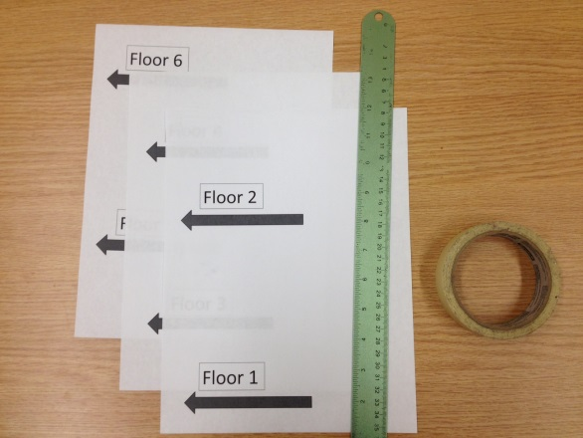

- Use the ruler to ensure six-inch spacing between floors 2 and 3. Apply masking tape.
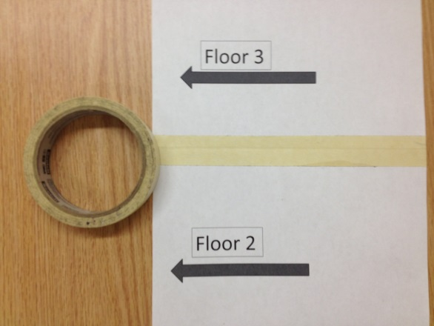
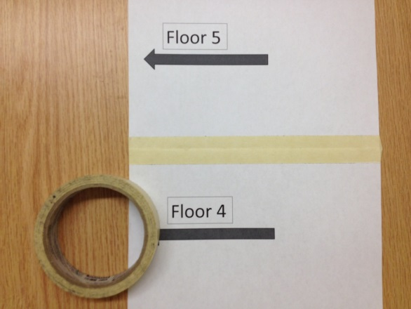
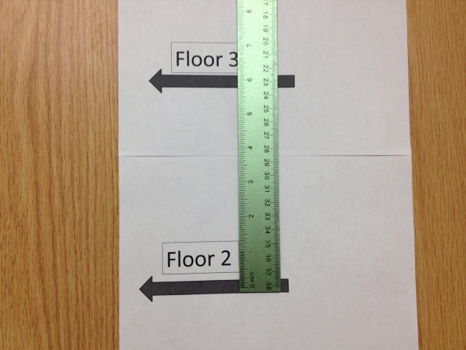

- Use the ruler to ensure six-inch spacing between floors 4 and 5. Apply masking tape.
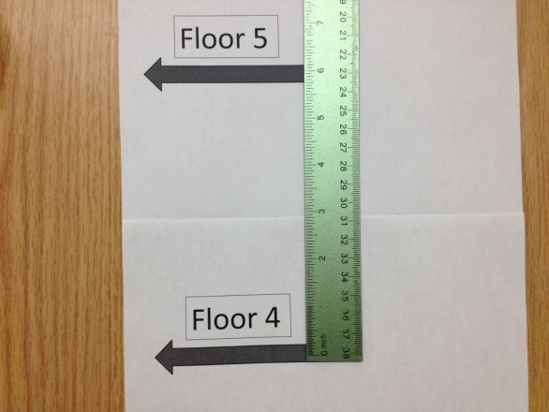

- Bend the bottom of the floor 1 arrow and align it to the ground.
