Rotary Encoders & Human-Computer Interaction —
Results and Analysis Worksheet – ANSWERS

- In your experimentation with the LEGO rotary encoder, did your predicted angles match up with the computer angles? Do you think the numbers should match up? Explain.
No, the angles did not match up. Yes the numbers should match in theory. The angles only increase by 6 degrees in the program.
- After graphing pixels vs. length from your experiments, what is the relation between the amount of pixels moved on the screen for a given length traveled on paper?
The relation is linear and about 350 pixels on screen per inch on paper.
- Explain what a rotary encoder is.
A rotary encoder is an electro-mechanical device that converts the angular motion of an axle to an analog or digital code.
- List some examples of devices that have rotary encoders: elevators, robots, wheelchairs

- Briefly explain how a rotary encoder works.
The rotary encoder uses two color sensors and a patterned wheel to translate angular motion to a digital code.
- Did the robotics (LEGO EV3) setup help you better understand a rotary encoder? Explain your answer.
Yes, it was helpful to use a physical model.
- How familiar are you with the topic of angles, after this activity? Rate from 1 (not familiar) to 10 (very familiar): 10

- What do you think is the angle shown in each picture? (Write the answer in degrees)
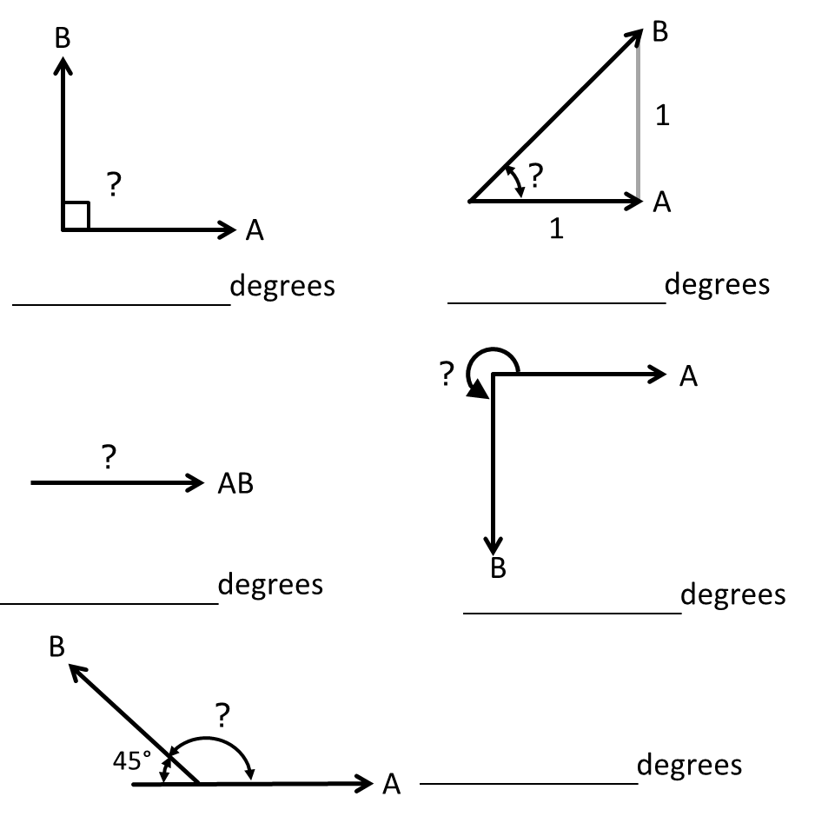
135
270
0 or 360
45
90

- Would the rotary encoder work for any other shapes, such as a square?
No, a square would cause some problems, such as uneven slits, weak encasing cover due to shape, or might not even register on the encoder depending on the slit location.
- How do you think rotary encoders are applied in elevators and fans? (Hint: Rotary encoders were used to relate rotation to distance in the computer mouse and rotation to angles in the LEGO device.)
An elevator regulates the distance of the elevator box as the motor turns. A fan can regulate the speed of the blades with an encoder.

