Rotary Encoders & Human-Computer Interaction —
Results and Analysis Worksheet

- In your experimentation with the LEGO rotary encoder, did your predicted angles match up with the computer angles? Do you think the numbers should match up? Explain.

- After graphing pixels vs. length from your experiments, what is the relation between the amount of pixels moved on the screen for a given length traveled on paper?

- Explain what a rotary encoder is.

- List some examples of devices that have rotary encoders:

- Briefly explain how a rotary encoder works.

- Did the robotics (LEGO EV3) setup help you better understand a rotary encoder? Explain your answer.

- How familiar are you with the topic of angles, after this activity? Rate from 1 (not familiar) to 10 (very familiar) ______________

- What do you think is the angle shown in each picture? (Write the answer in degrees)
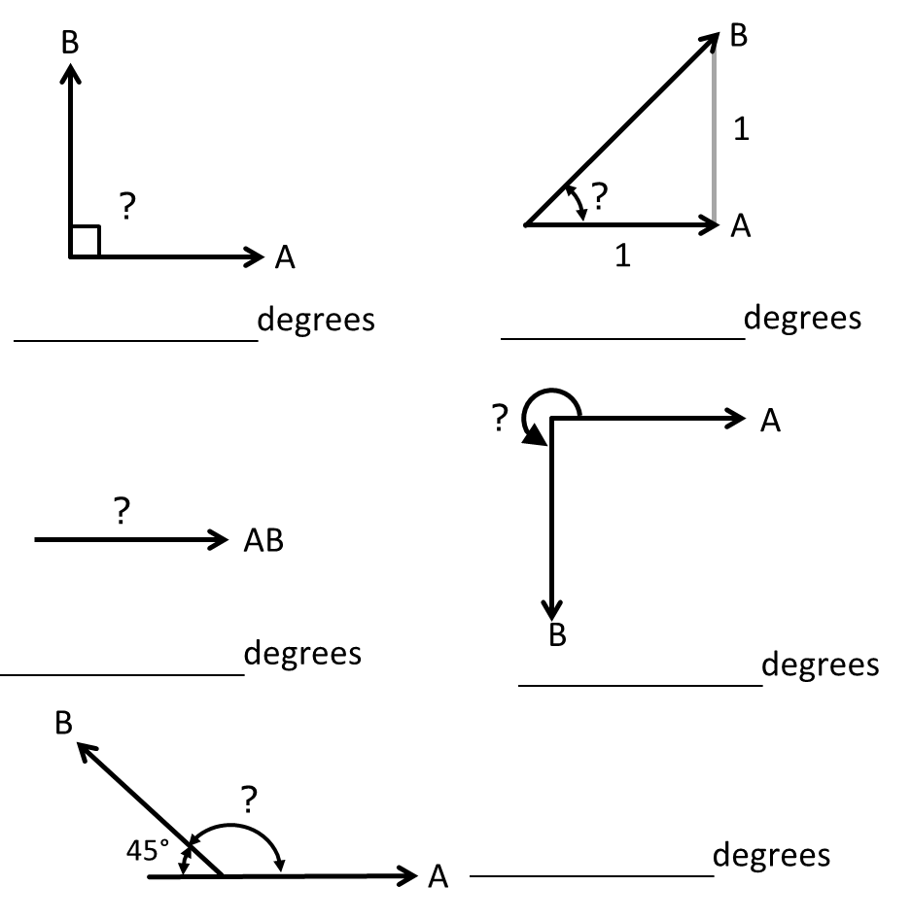

- Would the rotary encoder work for any other shapes, such as a square?

- How do you think rotary encoders are applied in elevators and fans? (Hint: Rotary encoders were used to relate rotation to distance in the computer mouse and rotation to angles in the LEGO device.)

