Friction Force Pre-Assessment
- Define friction:

- When you slide a book along a table, does friction make the book go faster or slower?

- The block below is sliding to the right on a table. Which way does the force of friction act?
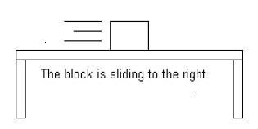

- Which of the following has a GREATER friction force (circle on):
  - Riding a bike on tile floors.
  - Riding a bike outside on grass.

- Why do you think engineers would design car tires to have a rubber coating?

- Did working with robotics help you understand friction? Please explain.

