Friction Force Pre-Assessment ANSWER KEY
- Define friction:
Friction is a force that causes change in motion. This is because friction opposes the relative motion of surfaces in contact.

- When you slide a book along the table, does friction make the book go faster or slower?
Friction makes the book go slower because it opposes the motion of the book. In fact, the book will eventually come to a stop due to friction.

- The block below is sliding to the right on a table. In which direction does the friction force act?
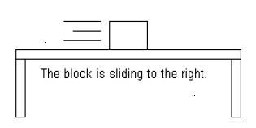
The friction force acts to the left so that it slows the block down.

- Which of the following scenarios has a GREATER friction force (circle one):
  - Riding a bike on tile flooring.
  - Riding a bike outside on the grass.

