How to Pull Something Heavy Homework
- Draw a diagram showing all the forces acting on the cars tugging each other in opposite directions.

- “On April 4, 1974, John Massis of Belgium managed to move two passenger cars belonging to New York’s Long Island Railroad. He did so by clamping his teeth down on a bit that was attached to the cars with a rope and then leaning backward while pressing his feet against the railway ties. The cars together weighted about 80 tons.”
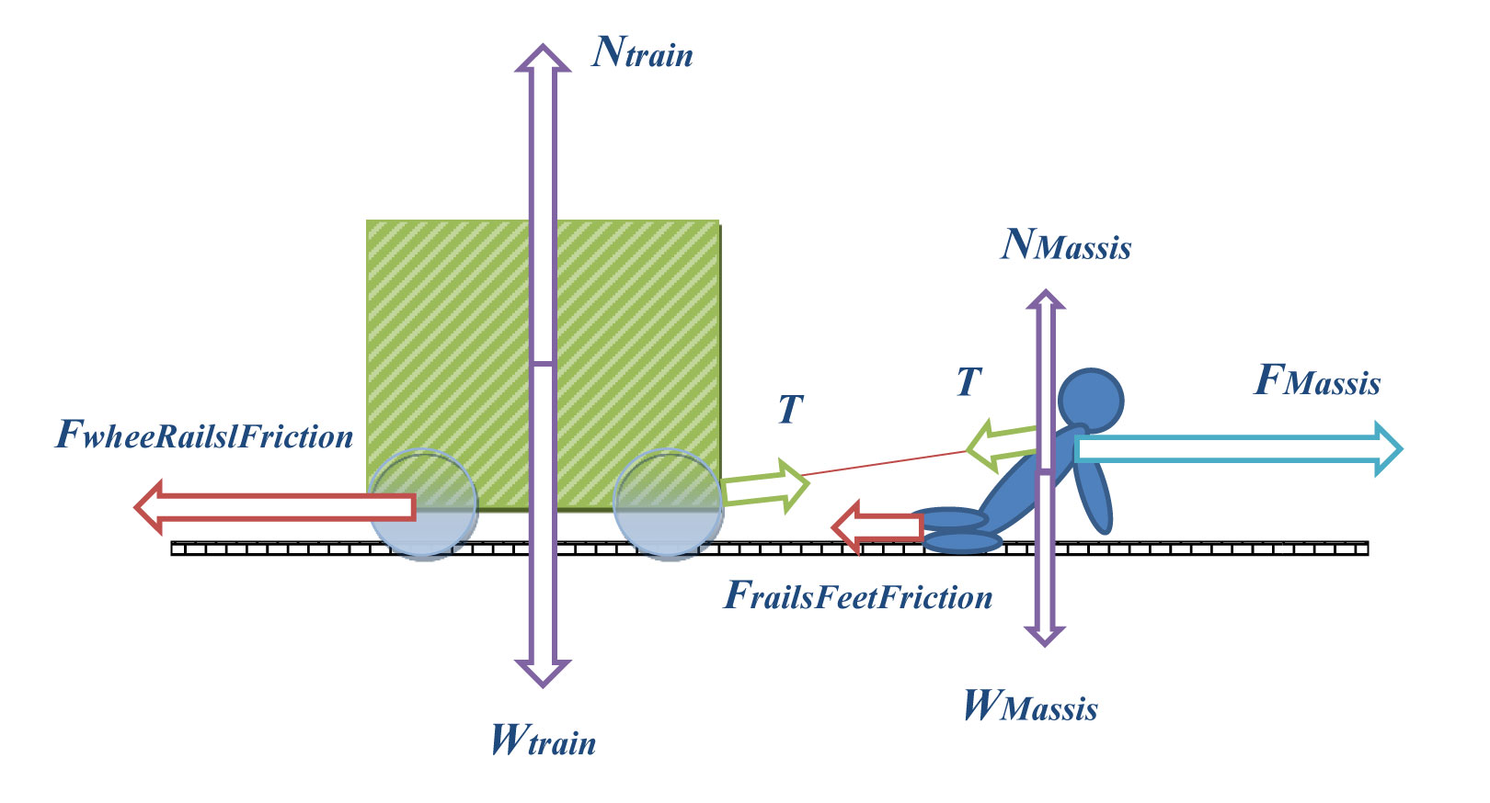
Draw a free body diagram representation for Massis’ challenge.

