Linear Equations Quiz Answer Key

- Determine and write the linear equation for a line that will safely pass through the gates below.
Draw the line.
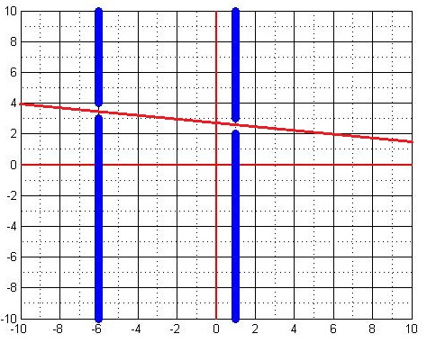
Since this question has no exact answer, use the following to check students’ answers:
- Plug in X=-6 into the student’s equation; if the resulting Y is greater than 3 and less than 4 (3 < y < 4), then the student has passed the first gate.
- Plug in X=1 into the student’s equation; if the resulting Y is greater than 2 and less than 3 ( 2 < y < 3), then the student has passed the second gate.
- Both of these conditions must be true, in order to pass both gates.
- An example correct equation: y = $-\frac{1}{7}x+ \frac{37}{14}$

- What benefits does modeling in engineering provide?
Answers will vary. Example answers:
- Modeling allows engineers to foresee problems before they happen in real life.
- Modeling allows engineers to plan the most-effective routes, which can save the waste of supplies such as food, time and fuel.
- Modeling provides a method of testing something before it is used in the real world, reducing the threat to human life and property.
- Modeling allows engineers to use forensic techniques to see what went wrong.

