Activity 2: Making an LED Blink Worksheet
Overview
In this activity, we will connect an (external) LED to an Arduino using jumper wires and a breadboard, and then program the Arduino to cause the LED to blink.
Construct the Hardware
- Gather the following materials:
- 1 Arduino and USB cable
- 1 breadboard and 2 jumper wires
- 1 LED and 1 220Ω resistor
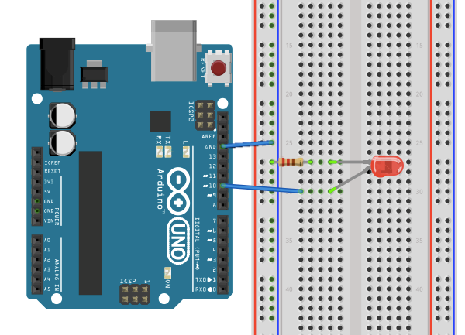
- Construct the following setup:

- Connect 1 jumper wire from GND (“ground”) to one of the (-) columns.
- Place 1 leg of the resistor in the same column as the GND wire. Place the other leg of the resistor in a new row.
- Place the short leg of the LED to the same row as the resistor leg. Place the long leg in a new row.
- Connect 1 jumper wire from the previous row to digital pin 10.
- Check that your setup matches the setup in the diagram above or the one at the front of the room.
Create the Program
- Type up the associated program for Activity 2 (see the next page).
Tip: Capitalization and spelling matter. Note: most lines of the code end in a semi-colon.
- Save the file as LED_Blink.
- To check that the Arduino can compile your code, “Verify” it. Do this by either pressing
Command + R or by clicking on the Verify button (it looks like a check mark).
Note: This does not upload the program to the Arduino board. This operation only checks to make sure that the Arduino will be able to execute it.
Note: If the file does compile without errors, this does not necessarily mean that there are no issues with your code.
/*
Activity 2: LED_Blink
Turns on an external LED on for one second, then off for one second, repeatedly.
*/

// Identify the digital pin to which the LED is connected:
int led = 10;

// The setup() routine runs only once:
void setup() {

// Set the digital pin as an output.
pinMode(led, OUTPUT);

}

// The loop routine runs over and over again forever:
void loop() {

digitalWrite(led, HIGH);
delay(1000);

digitalWrite(led, LOW);
delay(1000);

}
Troubleshoot Errors
- Error messages pop up in orange text the bottom of the IDE window. The computer tells you where (what lines) it believes the errors in the program are located (though it is not always right).
- Start by reading the first error message and checking that line of code. Compare what you have written to the original program. Common errors:
- If you get the message “________ was not declared in this scope,” it is possible you misspelled one of the variables or functions.
- If you get the message “expected ‘;’ before ____” —that means you forgot to add a semi-colon at the end of the previous line.
Run the Program
- Using the USB cable, connect your Arduino to your computer. Expect to see some lights flash on the Arduino board. Then the Arduino starts to execute the last program that was uploaded to it.
- From the “Tools” menu in the Arduino IDE, make sure the appropriate serial port is selected.
- Now upload the “LED_Blink” sketch. To do this, hit Command + U. (Or, click on the Upload Button in the Arduino IDE, which looks like an arrow pointing to the right.)
- After a few seconds, expect the LED to start to blink! If it is not blinking, check your hardware first, and then your code.
Reflection Questions
- What do you think the function digitalWrite( ) does? What information must go in its parentheses for it to work?

- What do you think the function delay( ) does? What does the number inside its parentheses represent?

Alternatives
- Figure out how to change the blink-rate of the LED. For example, try to get the LED to blink twice as fast, twice as slow, or with a completely new pattern. Describe what you changed in the program to do this.

- Figure out how to add a second LED and get it to blink opposite the first LED (when the first one is on, the second one should be off). Sketch the new setup below and describe the changes you made to the program to accomplish this.

